CLUSTER ANALYSIS OF OBJECTIVELY MEASURED PHYSICAL ACTIVITY IN CHRONIC OBSTRUCTIVE PULMONARY DISEASE: A MULTICENTRIC CROSS-SECTIONAL STUDY

Rafael Mesquita^{1,2,}*, Gabriele Spina^{3,}*, Fabio Pitta⁴, David Donaire-Gonzalez⁵, Brenda M. Deering⁶, Mehul S. Patel⁷, Katy E. Mitchell⁸, Jennifer Alison⁹, Arnoldus J. R. van Gestel¹⁰, Stefanie Zogg¹¹, Judith Garcia-Aymerich⁵, Kylie Hill^{12,13}, Elisabeth A. P. M. Romme¹⁴, Samantha S.C. Kon⁷, Paul S. Albert¹⁵, Benjamin Waschki¹⁶, Dinesh Shrikrishna⁷, Sally J. Singh⁸, Nicholas S Hopkinson⁷, David Miedinger¹¹, Christine Jenkins¹⁷, Michael I. Polkey⁷, Sue C. Jenkins¹³, William D-C. Man⁷, Christian F. Clarenbach¹⁰, Nidia A. Hernandes⁴, Daniela Savi¹⁵, David R. Hillman¹⁸, Karina C. Furlanetto⁴, Zoe J. McKeough¹⁹, Sally Watts¹⁹, Li W. Cindy Ng¹³, Dina Brooks¹², Peter R. Eastwood¹⁸, Thaís Sant'Anna⁴, Kenneth Meijer²⁰, Selina Dürr¹¹, Malcolm Kohler¹⁰, Vanessa S. Probst^{4,21}, Ruth Tal-Singer²², Jörg Leuppi¹¹, Peter M.A. Calverley¹⁵, Frank W. J. M. Smeenk¹⁴, Julie Yates²², Richard W. Costello⁶, Roger Goldstein¹², Helgo Magnussen¹⁶, Emiel F.M. Wouters^{1,2}, Richard L. ZuWallack²³, Oliver Amft^{3,†}, Henrik Watz^{16,†}, and Martijn A. Spruit^{1,†}.
Martijn, these co-authors need to be included among the other co-authors:
- Beatriz Abascal-Bolado1,2 and Roberto P. Benzo2
1 Division of Pulmonary. Hospital U. Marqués de Valdecilla. IFIMAV (Spain).
2 Division of Pulmonary and Critical Care. Breathing and Behavior Laboratory. Mayo Clinic. Rochester, MN (USA).

- Diana Jarreta1 and Esther Garcia Gil1
1 R&D Centre, Almirall, Barcelona, Spain.

- Philippe Gagnon1 and François Maltais1
1 Centre de recherche, Institut Universitaire de cardiologie et de pneumologie de Québec, 2725 Chemin Ste-Foy Québec, Université Laval, Québec G1V 4G5, Canada.

- Barbara Vagaggini1 and Pierluigi Paggiaro1.
1Cardio-Thoracic and Vascular Department, University of Pisa, Italy.

- Anne Kirsten1 and Marco Gramm1
1 Pulmonary Research Institute at Hospital Grosshansdorf, Member of the German Centre for Lung Research, Grosshansdorf, Germany.

Department of Pediatrics and Pediatric Neurology, Cystic Fibrosis Center, Sapienza University of Rome, Rome, Italy.

*Joint first authors †Joint senior authors

¹Department of Research & Education, CIRO+, center of expertise for chronic organ failure+, Horn, The Netherlands.
²Department of Respiratory Medicine, Maastricht University Medical Center+ (MUMC+), Maastricht, The Netherlands.
³ACTLab, Signal Processing Systems, TU Eindhoven, Eindhoven, The Netherlands.
⁴Laboratório de Pesquisa em Fisioterapia Pulmonar, Departamento de Fisioterapia, Universidade Estadual de Londrina (UEL), Londrina, Paraná, Brazil.
⁵Centre for Research in Environmental Epidemiology (CREAL), Barcelona, Spain.
⁶Department of Respiratory Medicine, Beaumont Hospital, Dublin, Ireland.
⁷NIHR Respiratory Biomedical Research Unit, Royal Brompton & Harefield NHS Foundation Trust and Imperial College, London, United Kingdom.
⁸NIHR CLAHRC-LNR Pulmonary Rehabilitation Research Group, University Hospitals, Leicester, United Kingdom.
⁹Physiotherapy Department, Royal Prince Alfred Hospital, Sydney, NSW, Australia.
¹⁰Pulmonary Division, University Hospital of Zurich, Zurich, Switzerland.
¹¹Internal Medicine, University Hospital of Basel, Basel, Switzerland.
¹²Respiratory Medicine, West Park Healthcare Centre, Toronto, Canada.
¹³School of Physiotherapy and Curtin Health Innovation Research Institute, Curtin University, Perth, WA, Australia.
¹⁴Department of Respiratory Medicine, Catharina Hospital, Eindhoven, The Netherlands.
¹⁵School of Ageing and Chronic Disease, University Hospital Aintree, Liverpool, United Kingdom.
¹⁶Pulmonary Research Institute at Hospital Grosshansdorf, Member of the German Centre for Lung Research, Grosshansdorf, Germany.
¹⁷Woolcock Institute of Medical Research, The University of Sydney, Camperdown, Australia.
¹⁸Department of Pulmonary Physiology, Sir Charles Gairdner Hospital, Perth, WA, Australia.
¹⁹Clinical and Rehabilitation Sciences, The University of Sydney, Sydney, NSW, Australia.
²⁰Department of Human Movement Science, Faculty of Health, Medicine and Life Sciences, Maastricht University, Maastricht, The Netherlands.
²¹Centro de Pesquisa em Ciências da Saúde, Centro de Ciências Biológicas e da Saúde, Universidade Norte do Paraná (UNOPAR), Londrina, Paraná, Brazil.
²²GlaxoSmithKline, King of Prussia, PA, United States of America.
²³Department of Pulmonary and Critical Care, Saint Francis Hospital and Medical Center, Hartford, CT, United States of America.

Financial support: RM is supported by CNPq, Conselho Nacional de Desenvolvimento Científico e Tecnológico – Brazil (246704/2012-8). Point-One funding from AgentschapNL, Dutch Ministry of Economic affairs, Netherlands. FOR CENTRES: please add here your own financial support, if there is any.

Correspondence:
Rafael Mesquita, MSc, PT
Department of Research & Education, CIRO+, center of expertise for chronic organ failure+; Hornerheide 1, 6085 NM, Horn, The Netherlands; Telephone number: +31 475 587 645; Email: rafaelmesquita14@ymail.com
ABSTRACT (≤250 words)
Rationale:
Objectives:
Methods:
Measurements and main results:
Conclusions:

Keywords: chronic obstructive pulmonary disease; physical activity; principal component analysis; cluster analysis.
INTRODUCTION

Patients with COPD have lower physical activity (PA) levels compared to healthy elderly subjects.¹⁻³ Lower PA has been associated with various health outcomes in patients with COPD, including hospitalization and death.^{4,5} Therefore, a greater awareness of the clinical importance of physical inactivity in COPD is needed amongst healthcare professionals and scientists.REF

Different tools have been used to assess PA in patients with COPD, including patient-reported outcome questionnaires and activity monitoring.⁶ The use of activity monitors has become popular in patients with COPD, as these devices can provide more detailed information of PA levels during the day compared to questionnaires.^{7,8}

To date, most COPD studies that used activity monitors have reported only the average daily PA level and its standard deviation.⁹⁻¹² Donaire-Gonzalez and colleagues¹³ were the first to perform a more detailed analysis of PA in patients with COPD. Indeed, patients with COPD performed bouts of moderate-to-vigorous PA, and the frequency of these bouts was inversely associated with the degree of airflow limitation.¹³ Nevertheless, multiple other options are also available, such as temporal patterns of PA,¹⁴ and even PA cluster analysis.¹⁴⁻¹⁷

A temporal analysis of PA patterns can reveal whether specific physical activities are concentrated during certain periods of the day;¹⁴ while cluster analysis is able to identify subgroups of patients with similar PA patterns.¹⁸ This detailed information will provide a better insight in PA of patients with COPD. This may be also be of clinical importance, as many interventions thus far have failed to promote important increase mean PA levels in patients with COPD.^{19,20}

To the best of our knowledge, temporal patterns of PA and cluster analysis of levels of PA have not been investigated in patients with COPD. Therefore, we aimed: 1) to describe the heterogeneity of levels and patterns of PA in patients with COPD after stratifying for possible confounders; 2) to compare levels and patterns of PA between patients with COPD and healthy subjects, matched for age, gender and body mass index (BMI); 3) to identify clusters of patients with COPD based on levels of PA and; 4) to investigate and compare clinical characteristics and levels and patterns of PA between these clusters. Some of the results of the present study have been previously reported in the form of an abstract.REF

METHODS

Study design and participants
In this multi-center cross-sectional study, a secondary analysis of objectively assessed PA data from 10 different countries was performed. Researchers from the United Kingdom (UK), Ireland, the Netherlands, Germany, Switzerland, Italy, Spain, the United States of America (USA), Brazil and Australia on possession of published and/or unpublished PA data (with no overlapping analysis) as assessed by the activity monitor SenseWear Armband or SenseWear Mini Armband (both from BodyMedia Inc., Pittsburgh, PA, USA) were invited to share their data for the current analysis. References of previously published data can be found in the online supplement. Subjects were included if they presented: COPD with a post-bronchodilator forced expiratory volume in the first 1 s (FEV₁) / forced vital capacity (FVC) ratio <0.7²¹, stable condition (i.e., no recent exacerbation), and complete data for age, gender, BMI and daily levels of PA (see Physical activity assessment section for details). In almost all centers the studies were approved by the local Ethics Committee, and written informed consent was obtained from participants; in one center only (around 2% of the data) the assessments were part of the regular clinical assessments, and then no consent was obtained.

Demographics, anthropometrics, lung function, and clinical data were collected: age, gender, BMI (weight in kg per squared height in m),²² FEV₁ (% of predicted), FEV₁/FVC ratio, diffusion capacity of the lung for carbon monoxide (D_{LCO}, % of predicted), symptoms of dyspnea by the modified Medical Research Council (mMRC) dyspnea grade,²³ and the use of walking aids (yes/no) and long-term oxygen therapy (LTOT, yes/no). In addition, subjects were stratified by BMI (underweight (<18.5 kg∙m⁻²), normal weight (18.5 to 24.99 kg∙m⁻²), pre-obese (25 to 29.99 kg∙m⁻²), or obese (≥ 30 kg∙m⁻²))²⁴ and GOLD 1 to 4.²¹

Some centers also had available a sample of healthy subjects and were invited to also share this sample for the current analysis. These subjects had to fulfill the same inclusion criteria except those related to the diagnosis of COPD. As the sample of healthy subjects was smaller than the sample of patients with COPD, a sub-group of subjects from the latter sample was selected to be matched with the sample of healthy subjects, according to gender, age and BMI.

Physical activity assessment
The SenseWear Armband and SenseWear Mini Armband activity monitors (both from BodyMedia Inc., Pittsburgh, PA, USA) were used for the assessment of PA. These devices combine an accelerometer with different physiological sensors (i.e., a heat flux sensor, a galvanic skin response sensor, a skin temperature sensor, and a near-body ambient temperature sensor). Together with demographic characteristics, such as gender, age, height and weight, energy expenditure (EE) can be estimated using proprietary algorithms developed by the manufacturer. The SenseWear Armband has been shown to be valid in both field^{25,26} and laboratory studies.²⁷⁻²⁹ The following thresholds proposed by the American College of Sports Medicine (ACSM)³⁰ were used to classify the intensity of activities: very light intensity (VLI): <2.0 metabolic equivalents of task (MET); light intensity (LI): 2.0 to 2.9 METs; and moderate-to-vigorous intensity (MVI): ≥3.0 METs.

A minimum of four days (2 week days + Saturday + Sunday) was considered acceptable,⁹ with the device being used for ≥22 hours.³¹ For the cluster analysis, in order to reduce the variability in the data, only the results during waking hours and week days were considered. These results represent the average of all valid week days. Weekend days were used only for the presentation of daily hourly patterns. The software SenseWear Professional 6.1 was used for data analysis; only in a small portion of data (13% of subjects) version 7.0 had to be used instead. Regardless the version used, the software provides minute-by-minute EE and METs. These two variables were stratified according to different criteria (and the combination of them), using Matlab (version here) (Mathworks Inc., USA): intensity (e.g., VLI, LI and MVI), duration (e.g., bouts of activity), period of the day (e.g., before or after midday), frequency (e.g., number of bouts per day); and presentation (e.g., absolute numbers or percentage of total). These stratifications led to 180 variables, which were used for clustering and can be found in the online supplement (Table E1).

In the present study, bouts of at least 2 and 10 consecutive minutes were analyzed. Different guidelines recommend that subjects should engage in ≥30min·d-1 of activities of moderate-to-vigorous intensity, performing these activities in bouts of at least 10 minutesREF. This justifies the analysis of ≥10-minute bouts. Bouts of at least 2 minutes were also investigated in order to examine how subjects organize their activities, since 2 minutes is the minimum duration possible to be analyzed, as the software provides minute-by-minute data. In our study, the variables collected from the software are referred as levels of PA, while the term daily hourly patterns of PA is used in reference to the graphic representation of the median intensity per hour during a day averaged over all valid days included.

Statistical Analysis
Continuous variables were expressed as median (interquartile range), as most variables presented non-normal distribution. Categorical variables were expressed as absolute and/or relative frequency. Mann-Whitney U test or Kruskal-Wallis test (followed by Dunn’s test) was used for the comparison of continuous variables, while the chi-square test was used for categorical variables. Spearman coefficient was used to investigate correlations, when appropriate. All statistical analyses were performed using SPSS 17.0 (SPSS, Chicago, Illinois, USA) or GraphPad Prism 5 (GraphPad Software, La Jolla, California, USA).

Cluster analysis was adopted to identify groups of patients with distinct levels of physical activities. Firstly, the 180 variables generated after stratification of EE and METs were subjected to factor analysis, used for data reduction. As additive relationship was evident among some variables, Principal Component Analysis (PCA) was used to reduce the interaction between variables. This analysis produces components that can be then used to identify clusters of subjects. Each component consists of a set of variables among which some variables play a more relevant role than the others. Secondly, after PCA, K-means cluster analysis was used to group subjects according to the distribution of variables (standardized using Z-scores). These analyses were all performed using Matlab (version here) (Mathworks Inc., USA).

RESULTS

General characteristics
In total, 1001 patients with COPD fulfilled the inclusion criteria and were included in this multicentric study. The number of subjects per country of recruitment can be found in the online supplement (Table E2). Table 1 presents the general characteristics of the patients. Most of them were men and presented moderate-to-severe degree of airflow limitation, and only a small proportion was on LTOT or was user of walking aids.

TABLE 1. GENERAL CHARACTERISTICS OF THE PATIENTS WITH COPD
Characteristic | Value
N | 1001
Age, yrs | 67 (61 – 72)
Male, n / % | 654 / 65
Weight, kg | 74 (62 – 87)
Height, m | 1.70 (1.63 – 1.75)
BMI, kg·m⁻² | 25.8 (22.5 – 29.6)
BMI classification, %  Underweight  Normal weight  Overweight  Obese | 7  37  34  22
mMRC dyspnea grade* | 2 (1 – 3)
Long-term oxygen therapy, n / %† | 67 / 10
Walking aid, n / %‡ | 19 / 3
FEV₁, L | 1.31 (0.91 – 1.79)
FEV₁, % predicted | 49 (34 – 64)
FEV₁/FVC, % | 45 (35 – 56)
DLCO, % predicted§ | 51 (37 – 67)
GOLD grade 1/2/3/4, % | 9 / 40 / 34 / 17
Data expressed as absolute / relative frequency or median (interquartile range). BMI: body mass index; mMRC: modified Medical Research Council; FEV₁: forced expiratory volume in the first second; FVC: forced vital capacity; DLCO: diffusion capacity of the lung for carbon monoxide; GOLD: Global Initiative for Chronic Obstructive Lung Disease. *Data missing for 133 subjects; †Data missing for 294 subjects; ‡Data missing for 296 subjects; §Data missing for 496 subjects.

Daily levels and patterns of physical activity
The median number of valid days was 6 (6 – 6) days, but the sum of all valid days equaled to 6074 days, of which 4049 were week days. The PA assessments were almost evenly distributed among the four seasons of the year: summer, n=264 (26%); autumn, n=333 (33%); winter, n=229 (23%); and spring, n=175 (18%).

Table 2 presents the daily levels of PA during week days (the median number of week days was 4 (4 – 4) days). The smallest amounts of time and EE were spent in MVI. In general, these variables were almost 2 fold higher after midday than before midday, except for the results in MVI. Regarding bouts of PA, patients spent a median of 6 (0 – 22) min·day⁻¹ only in bouts of at least 10 minutes, but a median of 38 (17 – 79) min·day⁻¹ in bouts of at least 2 minutes. The latter had a median average duration of 4 (3 – 5) min·bout⁻¹ and were more frequent during the day than ≥10-minute bouts.

TABLE 2. DAILY LEVELS OF PHYSICAL ACTIVITY DURING WEEK DAYS IN PATIENTS WITH COPD
 | General physical activity
Variable | VLI | LI | MVI
Time, min∙day⁻¹  Before midday  After midday  Total | 283 (236 – 347)  514 (449 – 577)  803 (710 – 901) | 49 (31 – 74)  88 (53 – 123)  142 (92 – 194) | 21 (10 – 42)  27 (13 – 59)  52 (26 – 99)
EE, METs-min∙day⁻¹  Before midday  After midday  Total | 364 (274 – 502)  668 (521 – 858)  1032 (822 – 1327) | 154 (95 - 263)  273 (167 – 413)  435 (291 – 655) | 110 (46 – 232)  147 (65 – 310)  267 (132 – 550)
 | Bouts of physical activity
Variable | VLI | LI | MVI
Time, min∙day⁻¹  ≥2-minute  Before midday  After midday  Total  ≥10-minute  Before midday  After midday  Total | 273 (225 – 338)  503 (435 – 569)  781 (683 – 884)  215 (167 – 284)  436 (352 – 526)  657 (539 – 780) | 37 (22 – 59)  67 (37 – 97)  107 (65 – 156)  3 (0 – 8)  4 (0 – 14)  7 (0 – 22) | 15 (6 – 34)  20 (8 – 47)  38 (17 – 79)  2 (0 – 11)  3 (0 – 13)  6 (0 – 22)
Frequency, bouts∙day⁻¹  ≥2-minute  Before midday  After midday  Total  ≥10-minute  Before midday  After midday  Total | 21 (17 – 25)  27 (21 – 34)  48 (39 – 58)  7 (6 – 9)  11 (9 – 13)  18 (16 – 21) | 11 (7 – 16)  19 (11 – 26)  31 (20 – 41)  0 (0 – 1)  0 (0 – 1)  1 (0 – 2) | 4 (2 – 8)  5 (2 – 10)  10 (5 – 17)  0 (0 – 1)  0 (0 – 1)  1 (0 – 2)
Average duration, min∙bout⁻¹  ≥2-minute  Before midday  After midday  Total  ≥10-minute  Before midday  After midday  Total | 13 (10 – 17)  18 (13 – 27)  16 (12 – 21)  29 (24 – 36)  37 (29 – 50)  34 (28 – 43) | 3 (3 – 4)  3 (3 – 4)  3 (3 – 4)  10 (0 – 13)  11 (0 – 13)  12 (0 – 14) | 4 (3 – 5)  4 (3 – 5)  4 (3 – 5)  10 (0 – 15)  11 (0 – 15)  13 (0 – 16)
EE, METs-min∙day⁻¹  ≥2-minute  Before midday  After midday  Total  ≥10-minute  Before midday  After midday  Total | 347 (261 – 490)  648 (501 – 845)  1000 (783 – 1298)  273 (193 – 411)  572 (410 – 783)  847 (626 – 1168) | 118 (67 – 205)  211 (119 – 335)  340 (204 – 523)  6 (0 – 26)  14 (0 – 47)  26 (0 – 77) | 86 (29 – 187)  106 (41 – 255)  205 (86 – 436)  9 (0 – 61)  12 (0 – 69)  36 (0 – 132)
Data expressed as median (interquartile range). VLI: very light intensity; LI: light intensity; MVI: moderate-to-vigorous intensity; EE: energy expenditure; MET: metabolic equivalent of task.

Stratification for possible confounders
Daily levels of PA after stratification for general characteristics can be found in the online supplement (Tables E3-E10). Briefly, older subjects, women, subjects on LTOT, subjects making use of walking aids and subjects with a lower DLCO spent less time and EE in MVI than their counterparts, considering both non-bouts and bouts analyses. Obese subjects, subjects with a mMRC grade of 4 and subjects with a GOLD grade of 3 or 4 also presented reduced time and EE in MVI. Figure 1 presents the hourly pattern during week and weekend days after stratification for general characteristics. In general, there is almost no influence of age, gender, use of LTOT, and DLCO on the hourly patterns. On the other hand, there is an obvious influence of BMI, mMRC grades, and use of walking aids. The influence of GOLD grades on the hourly patterns is small. It was also observed a weak correlation between the degree of airflow limitation and the time in MVI (r_{s}=0.20, P<0.0001; Figure 2).
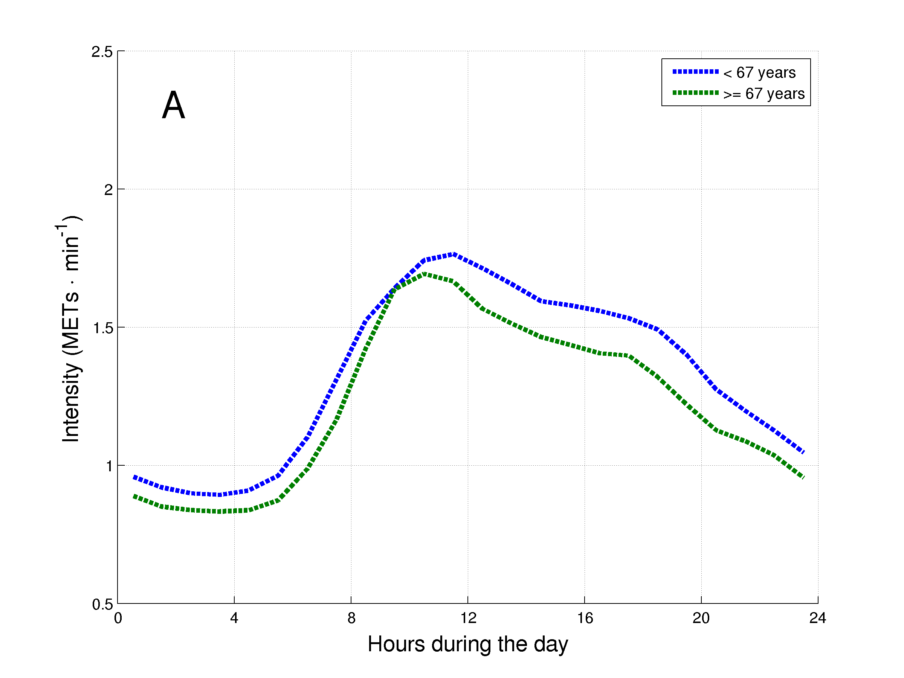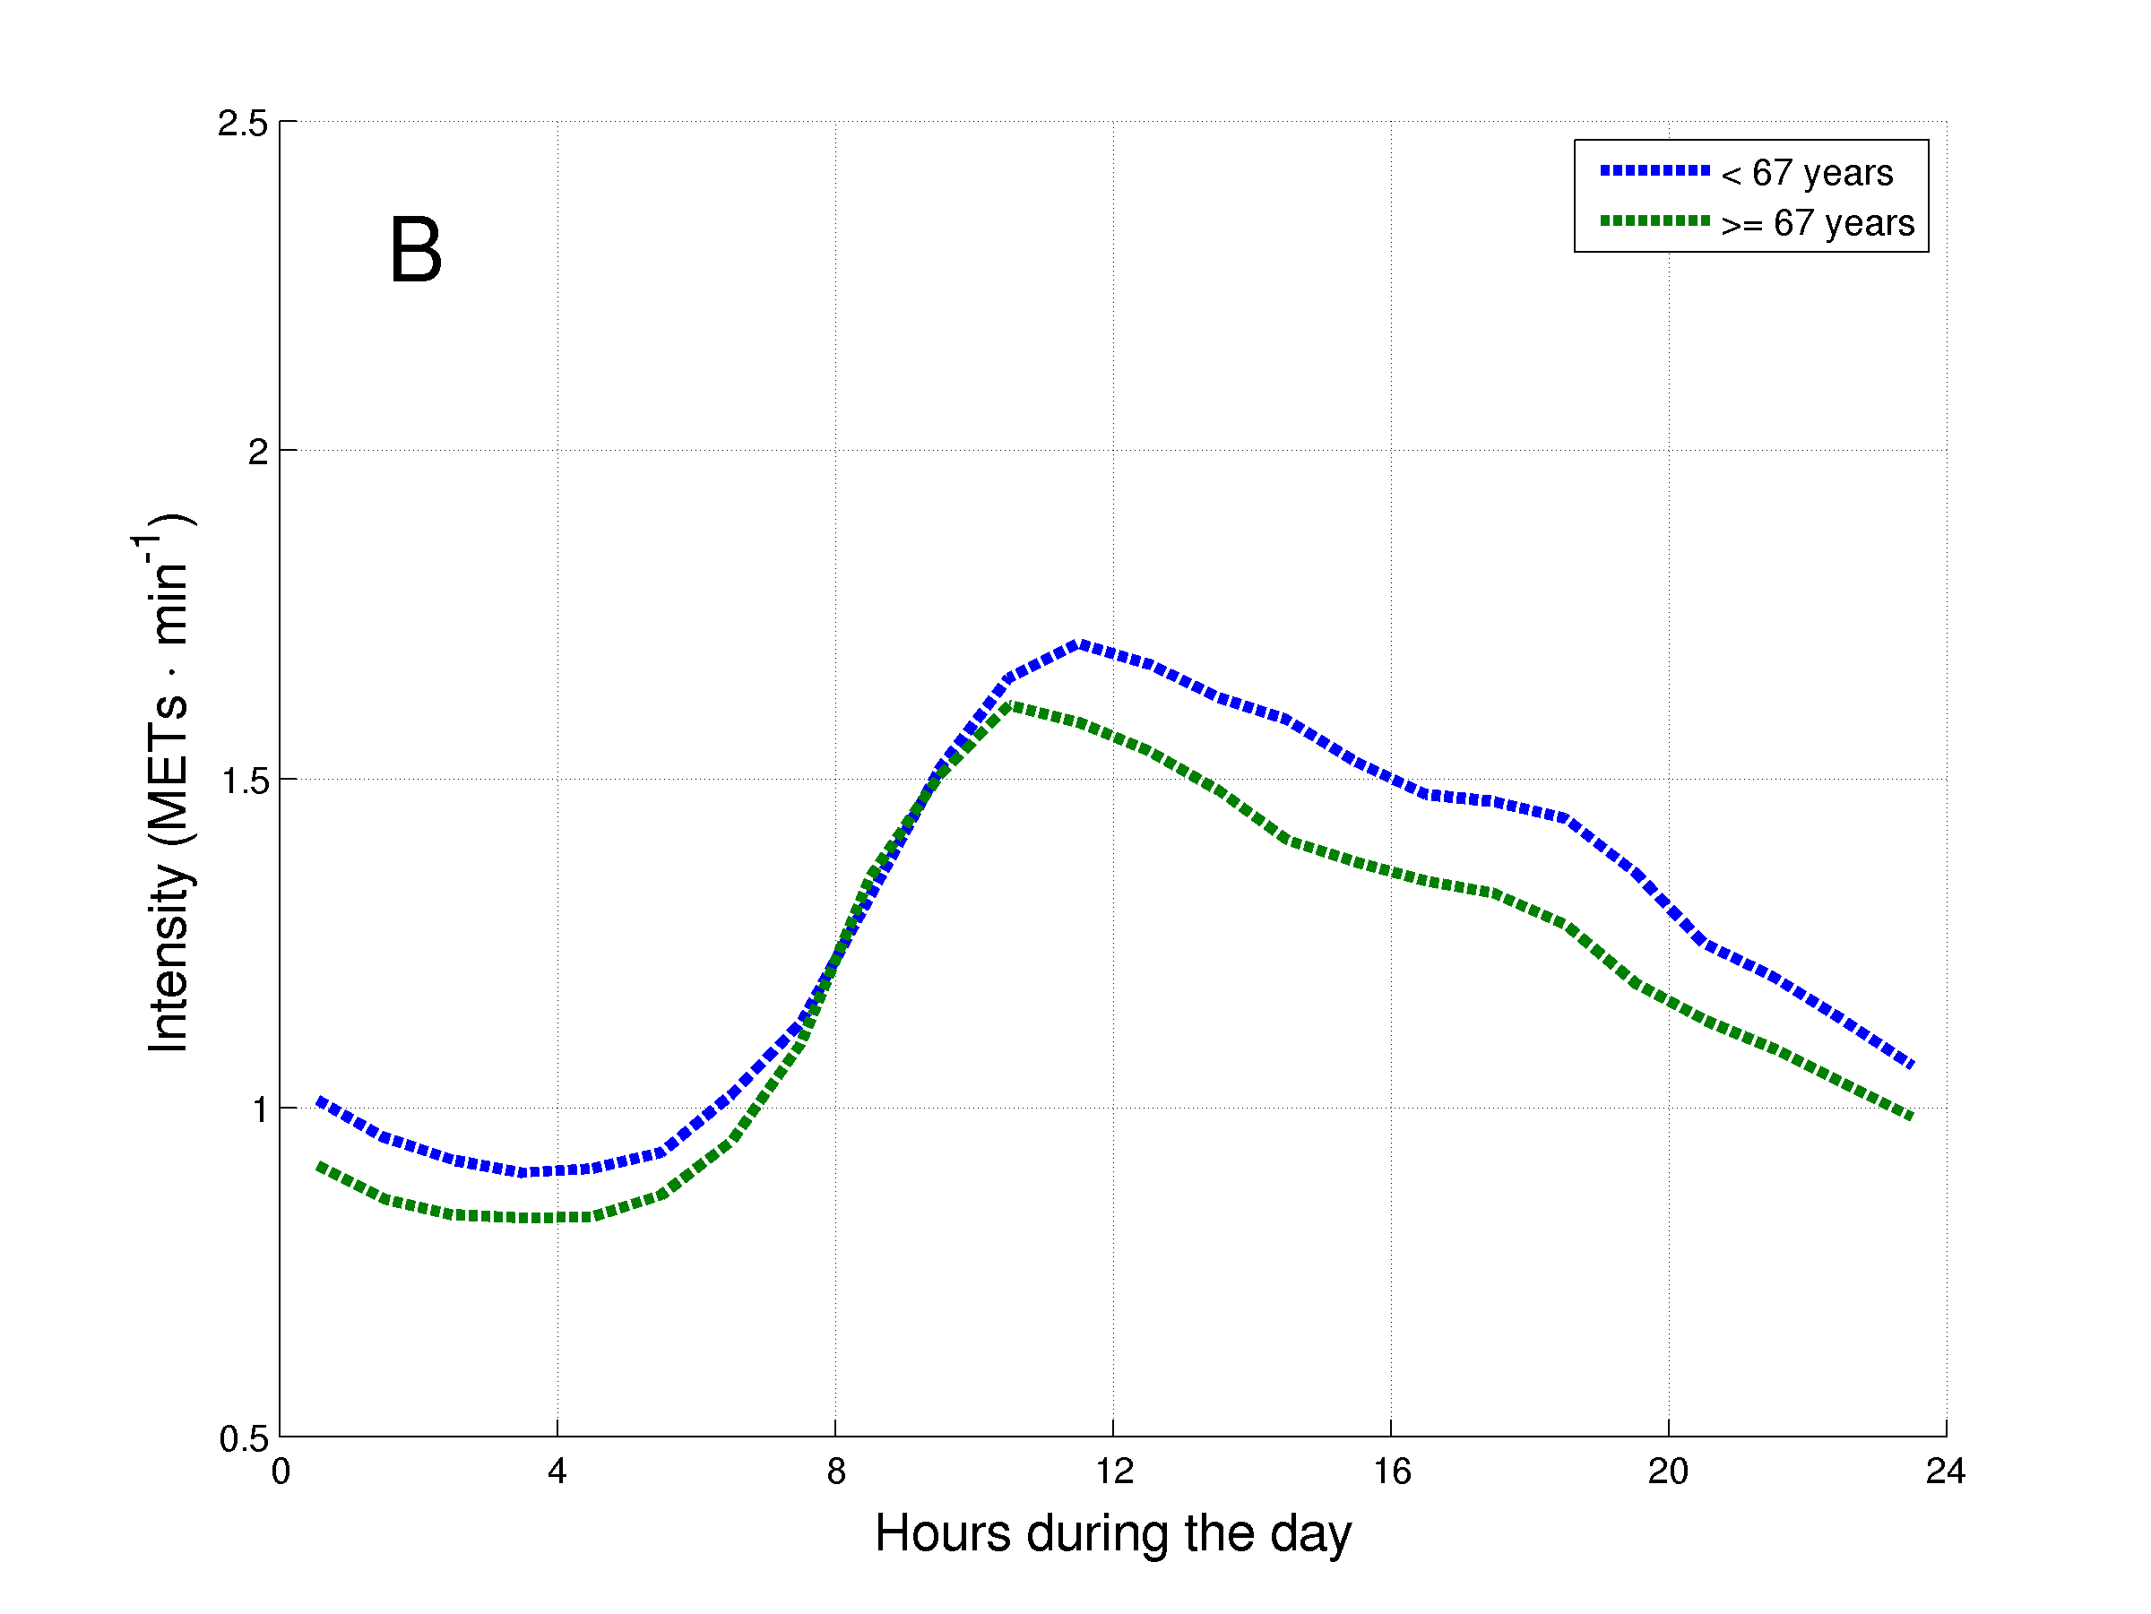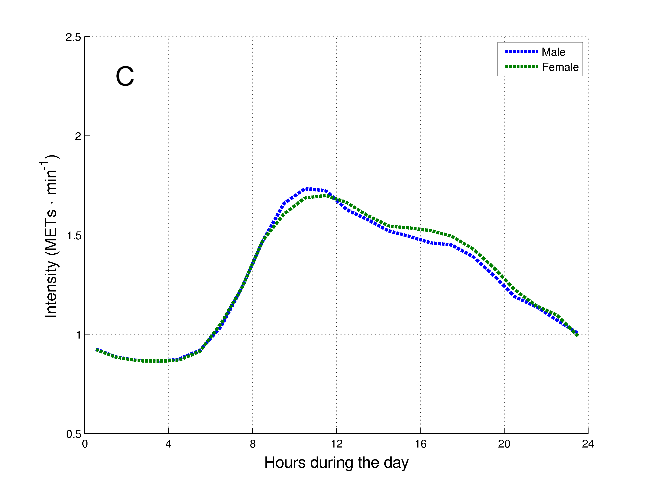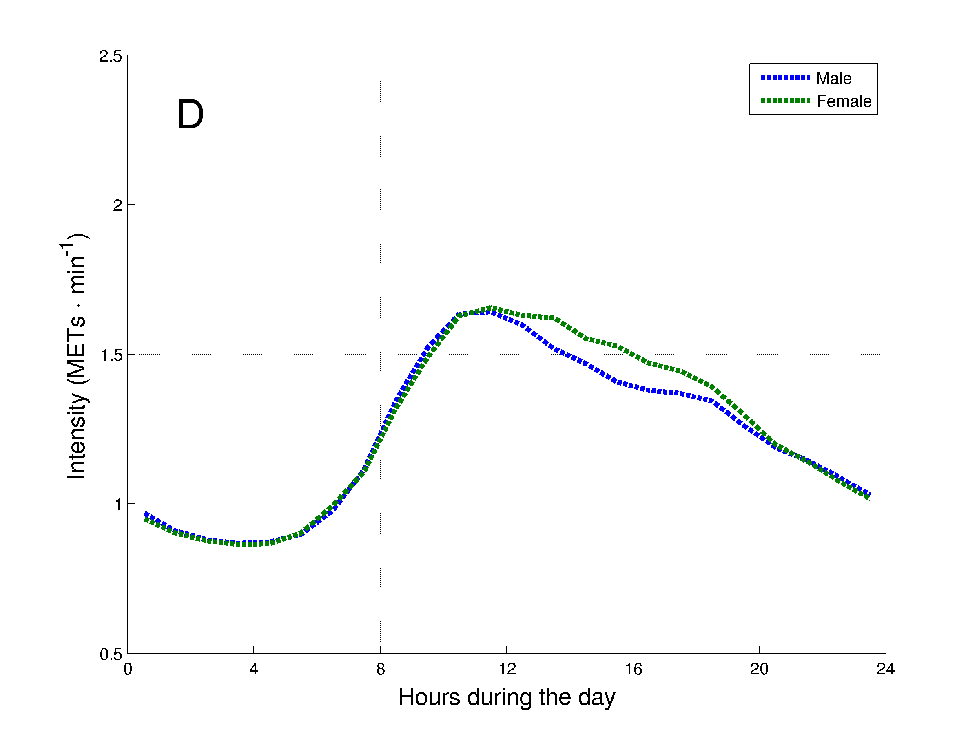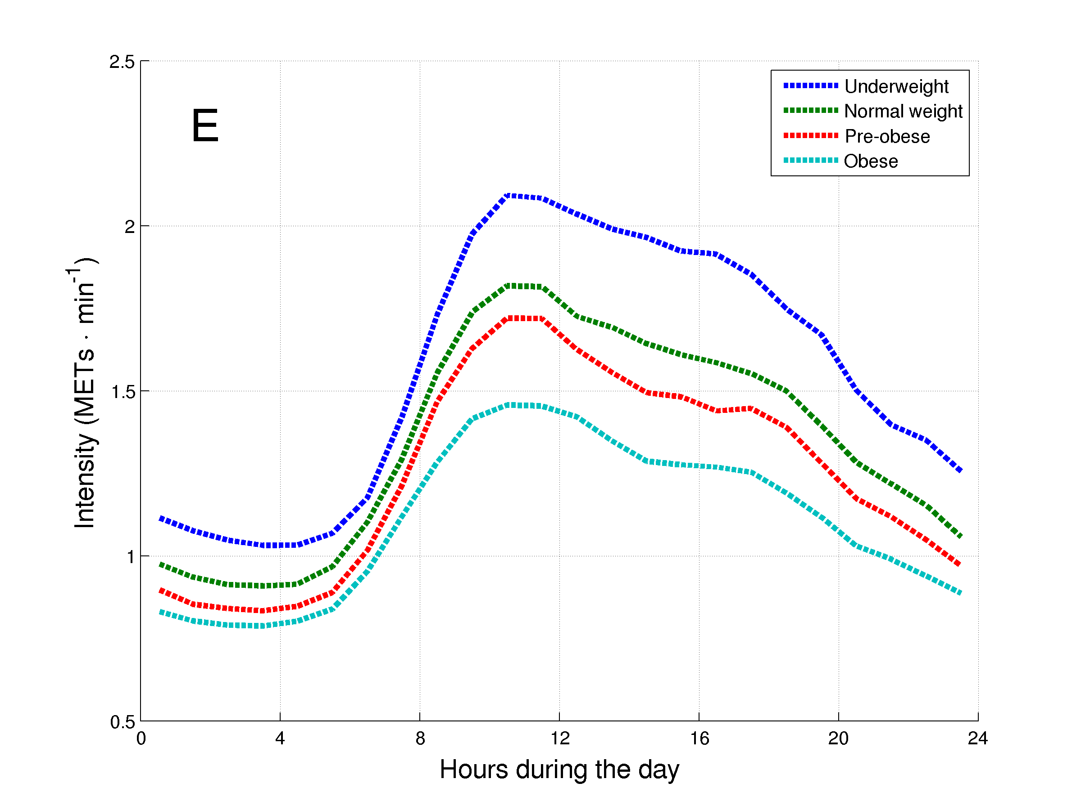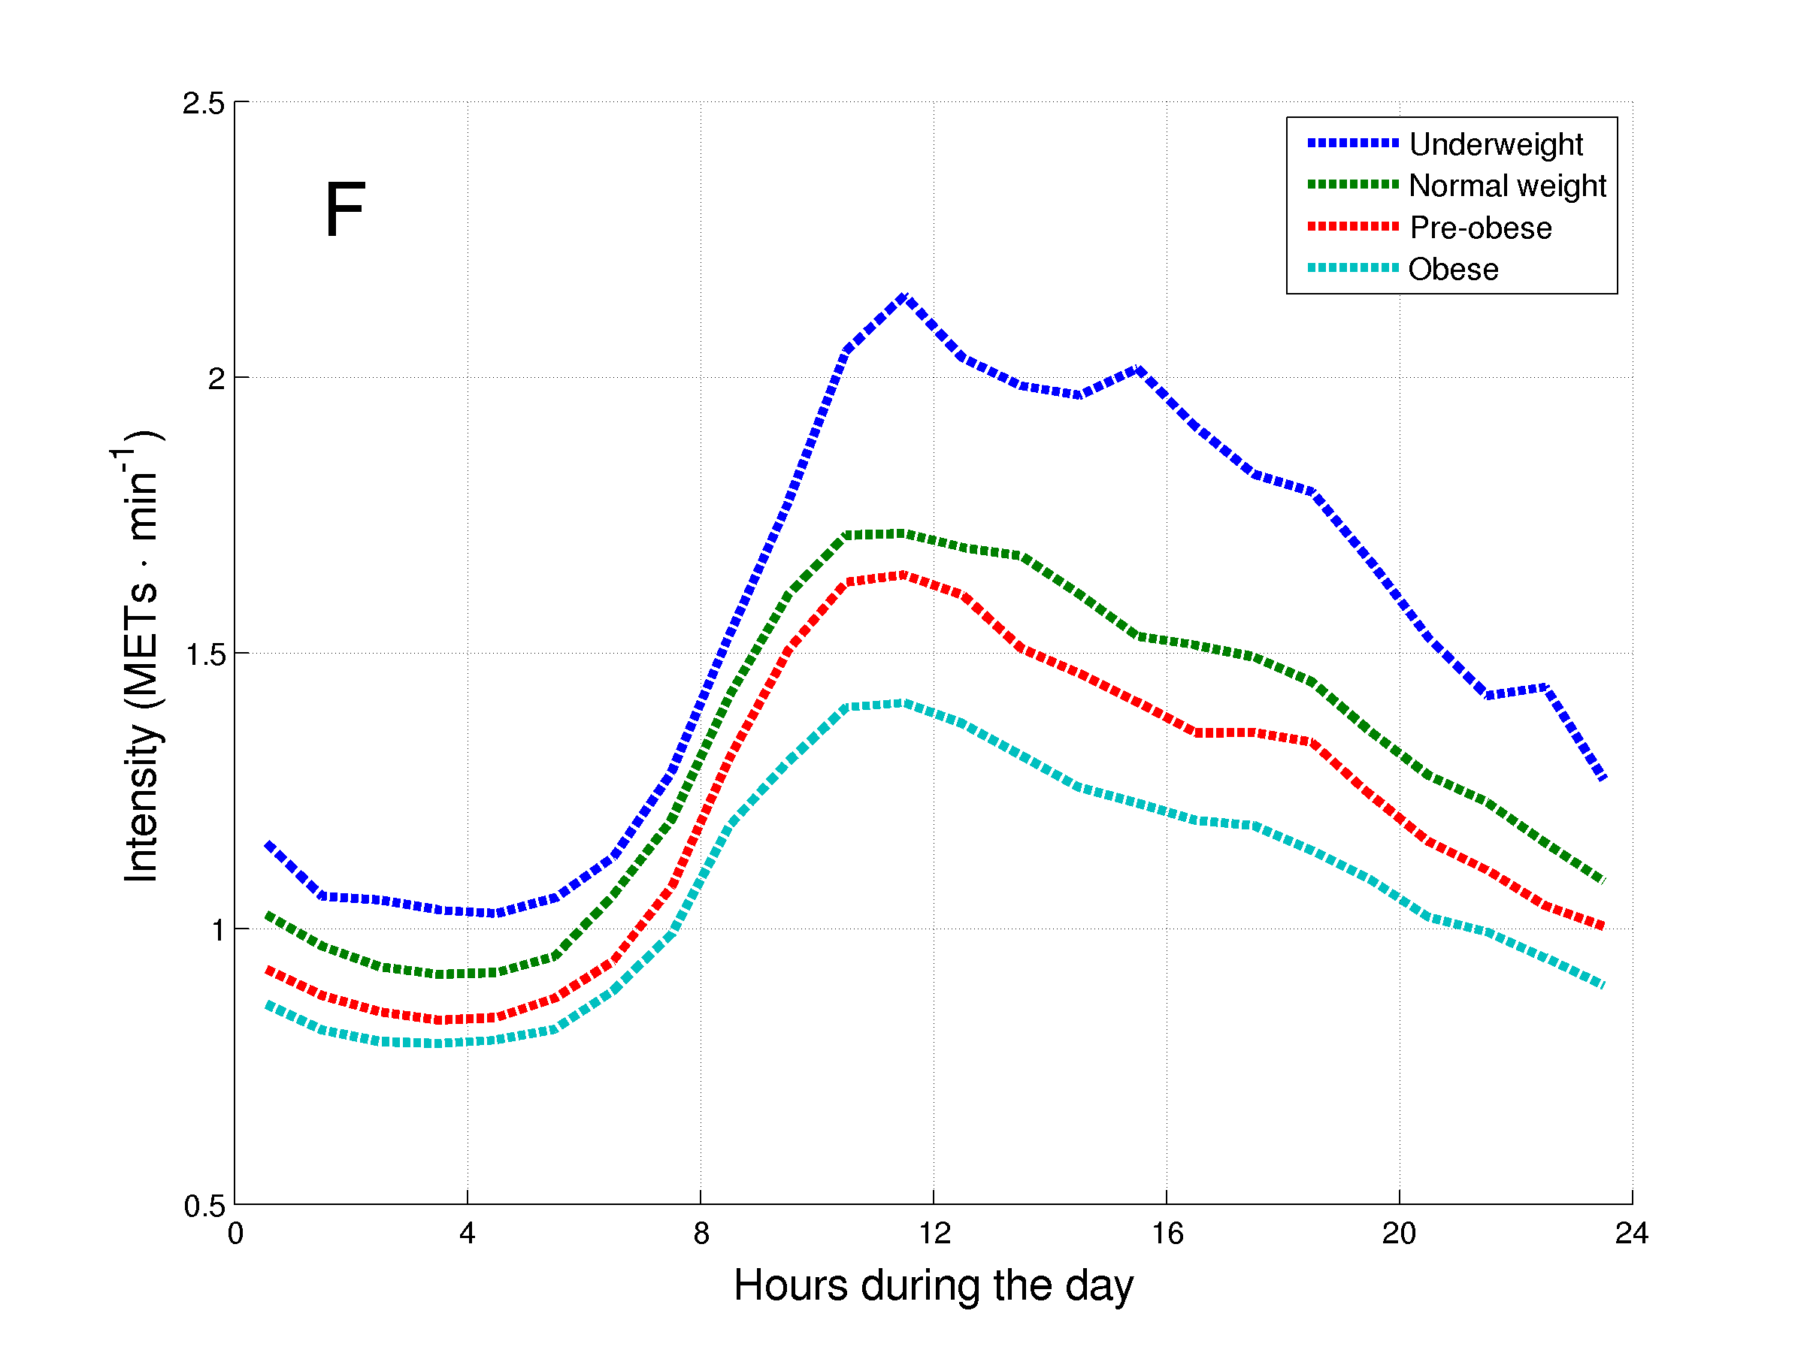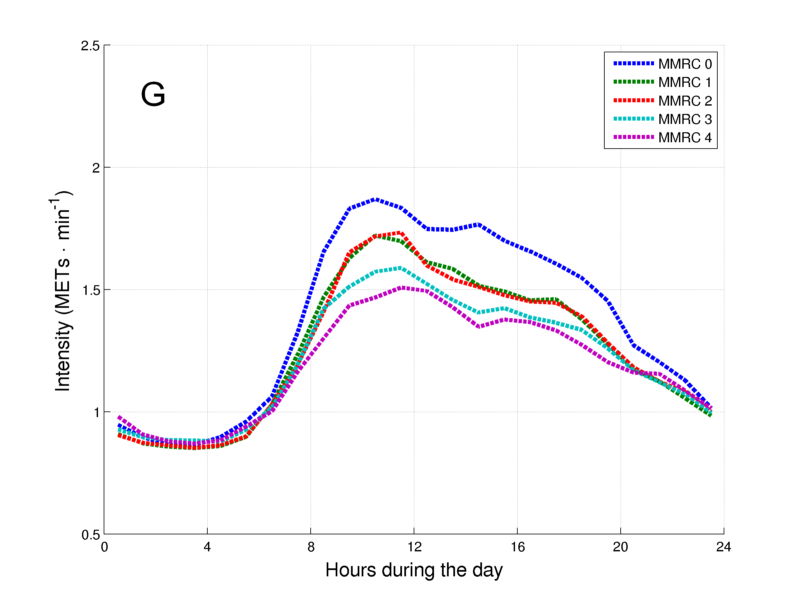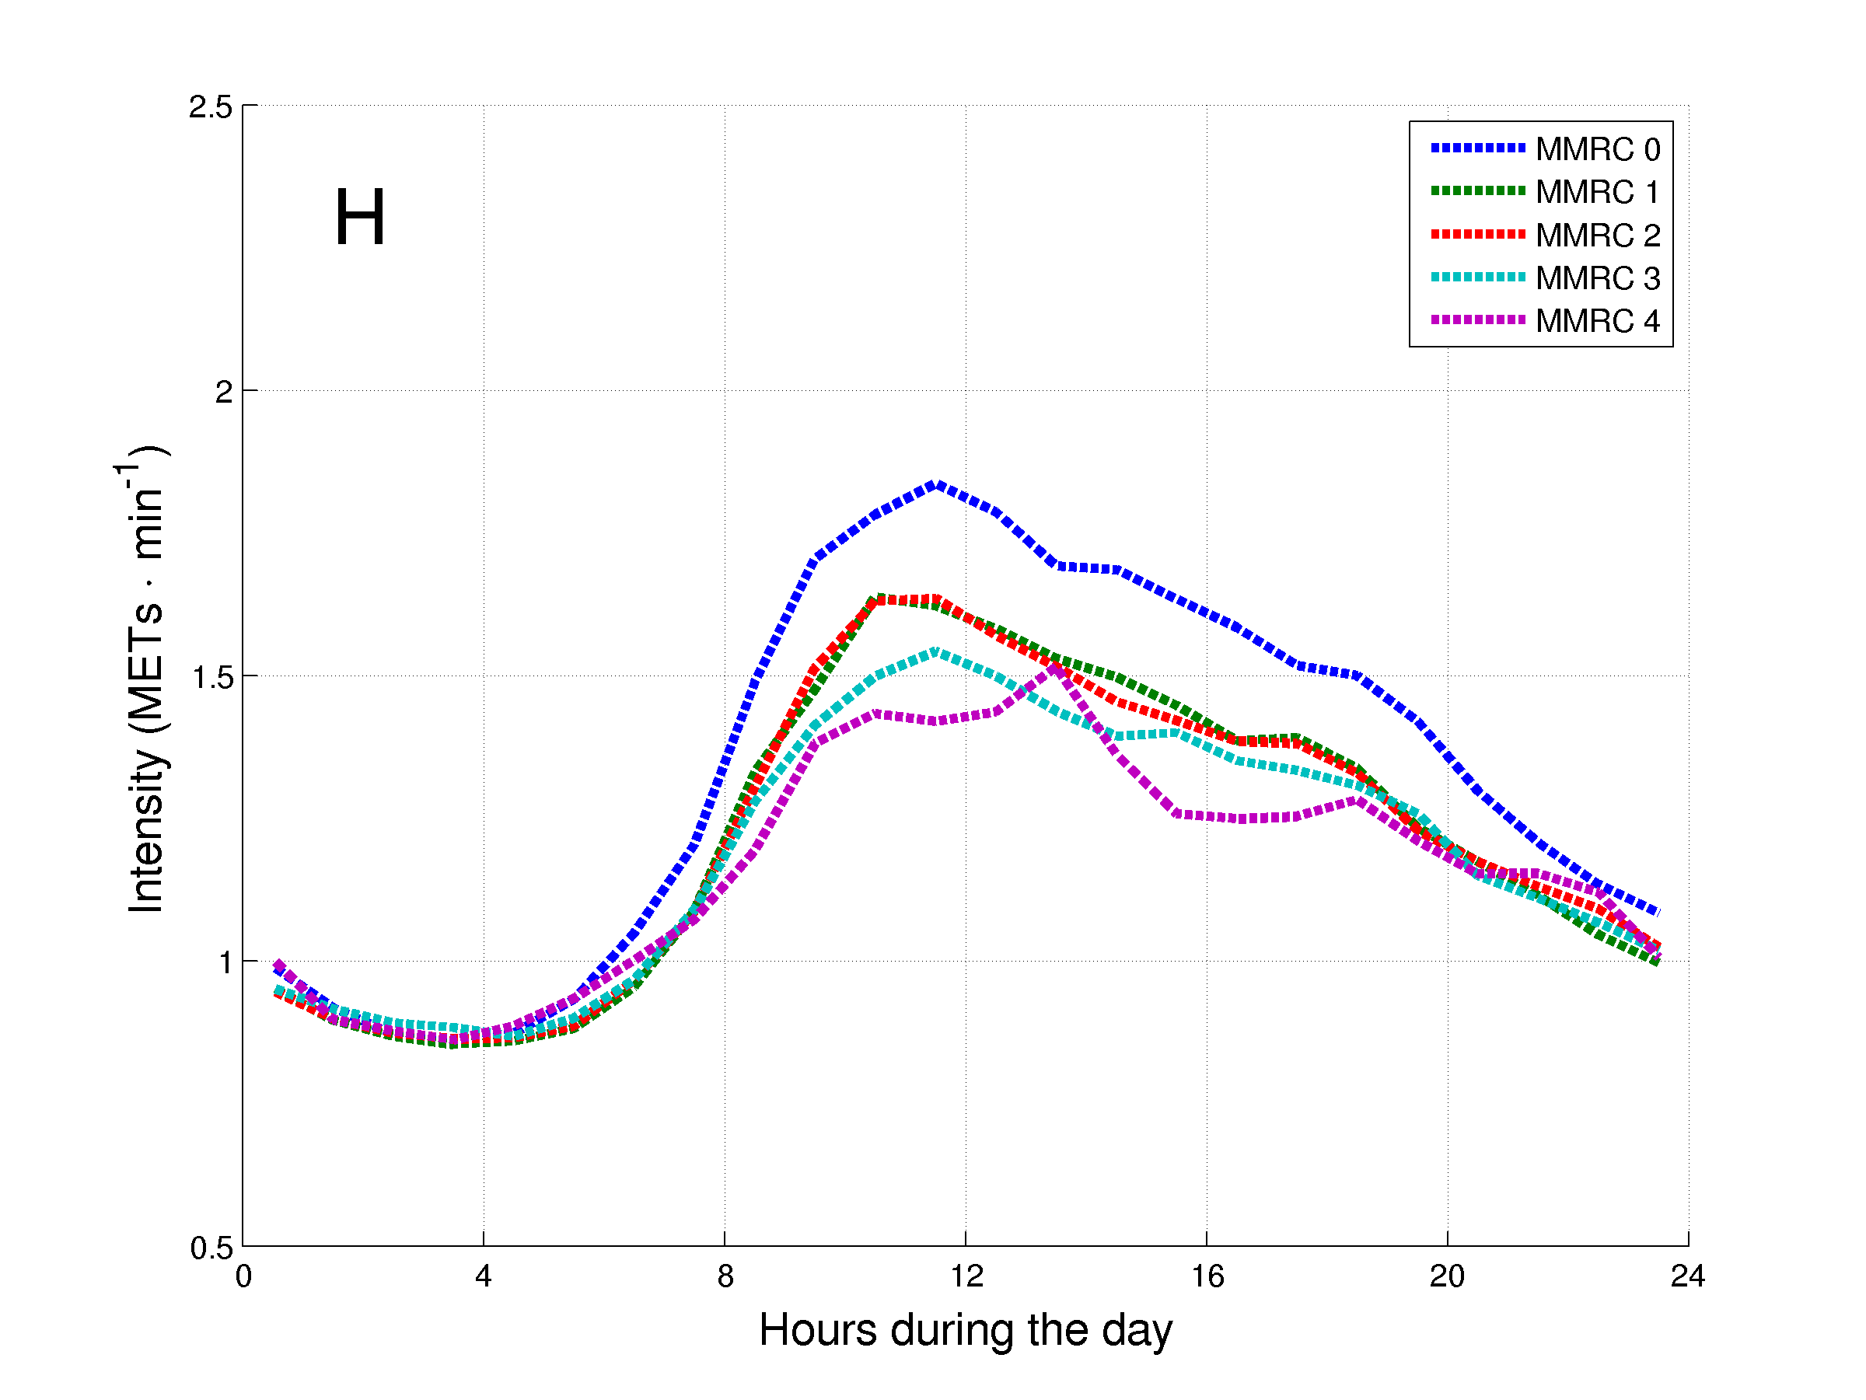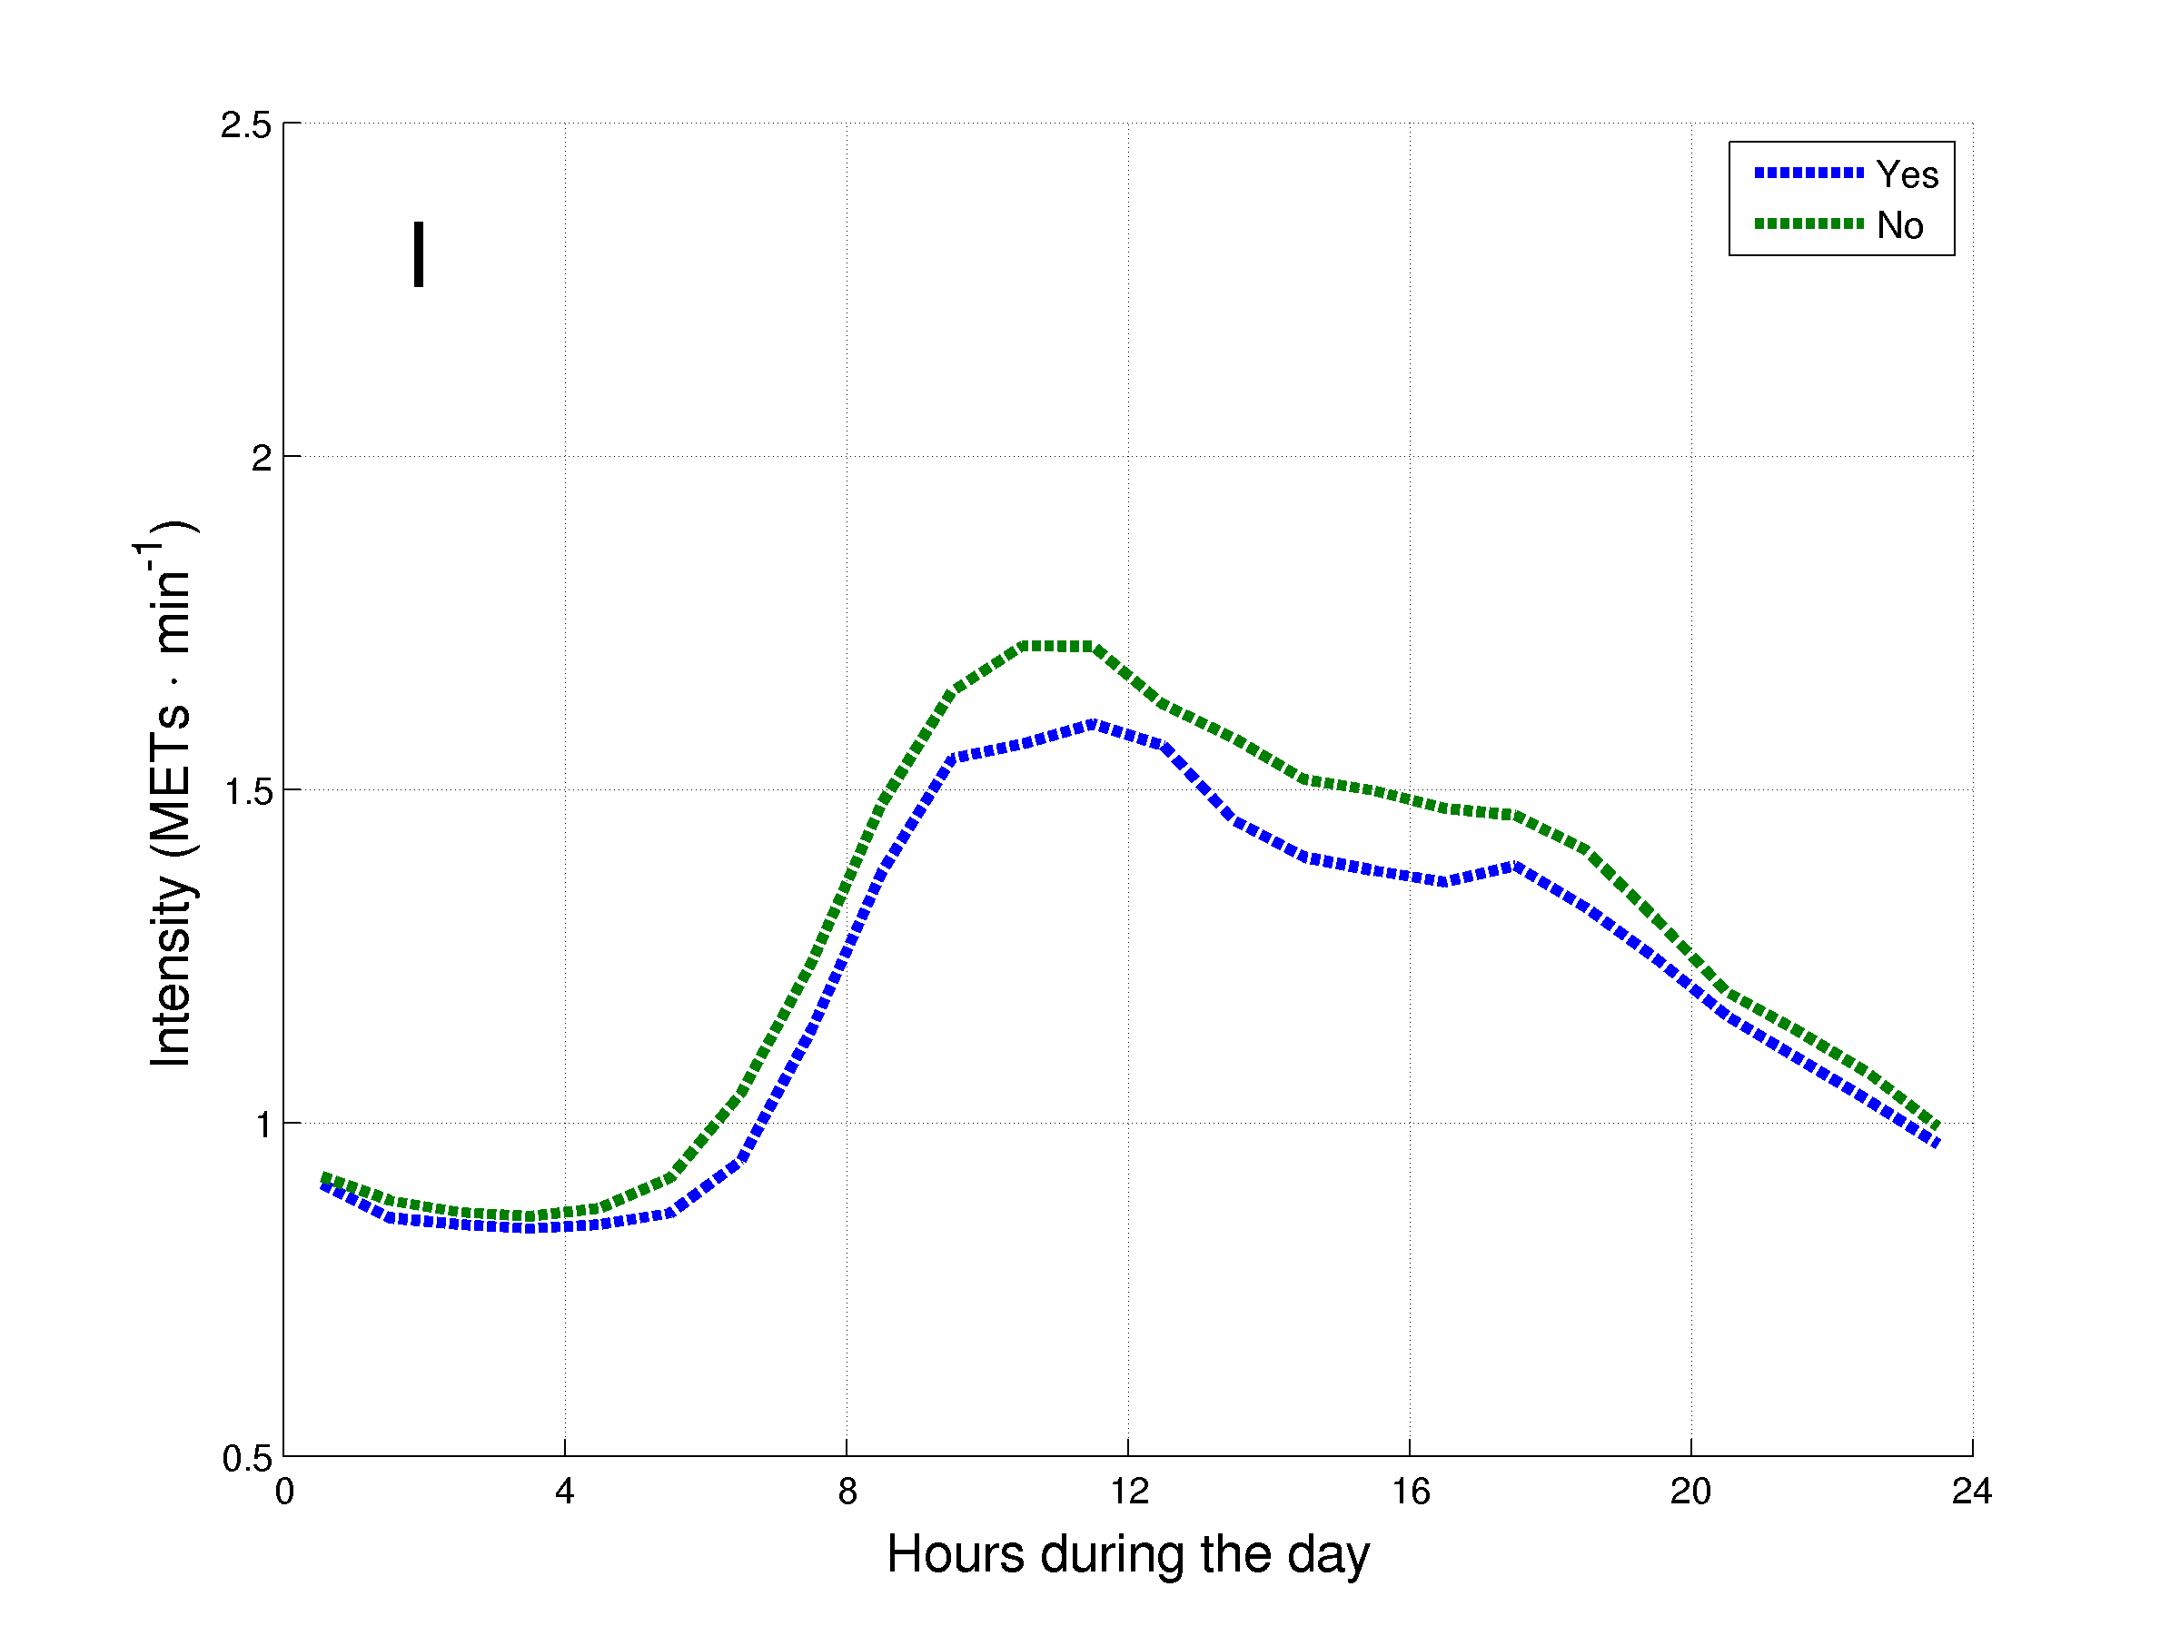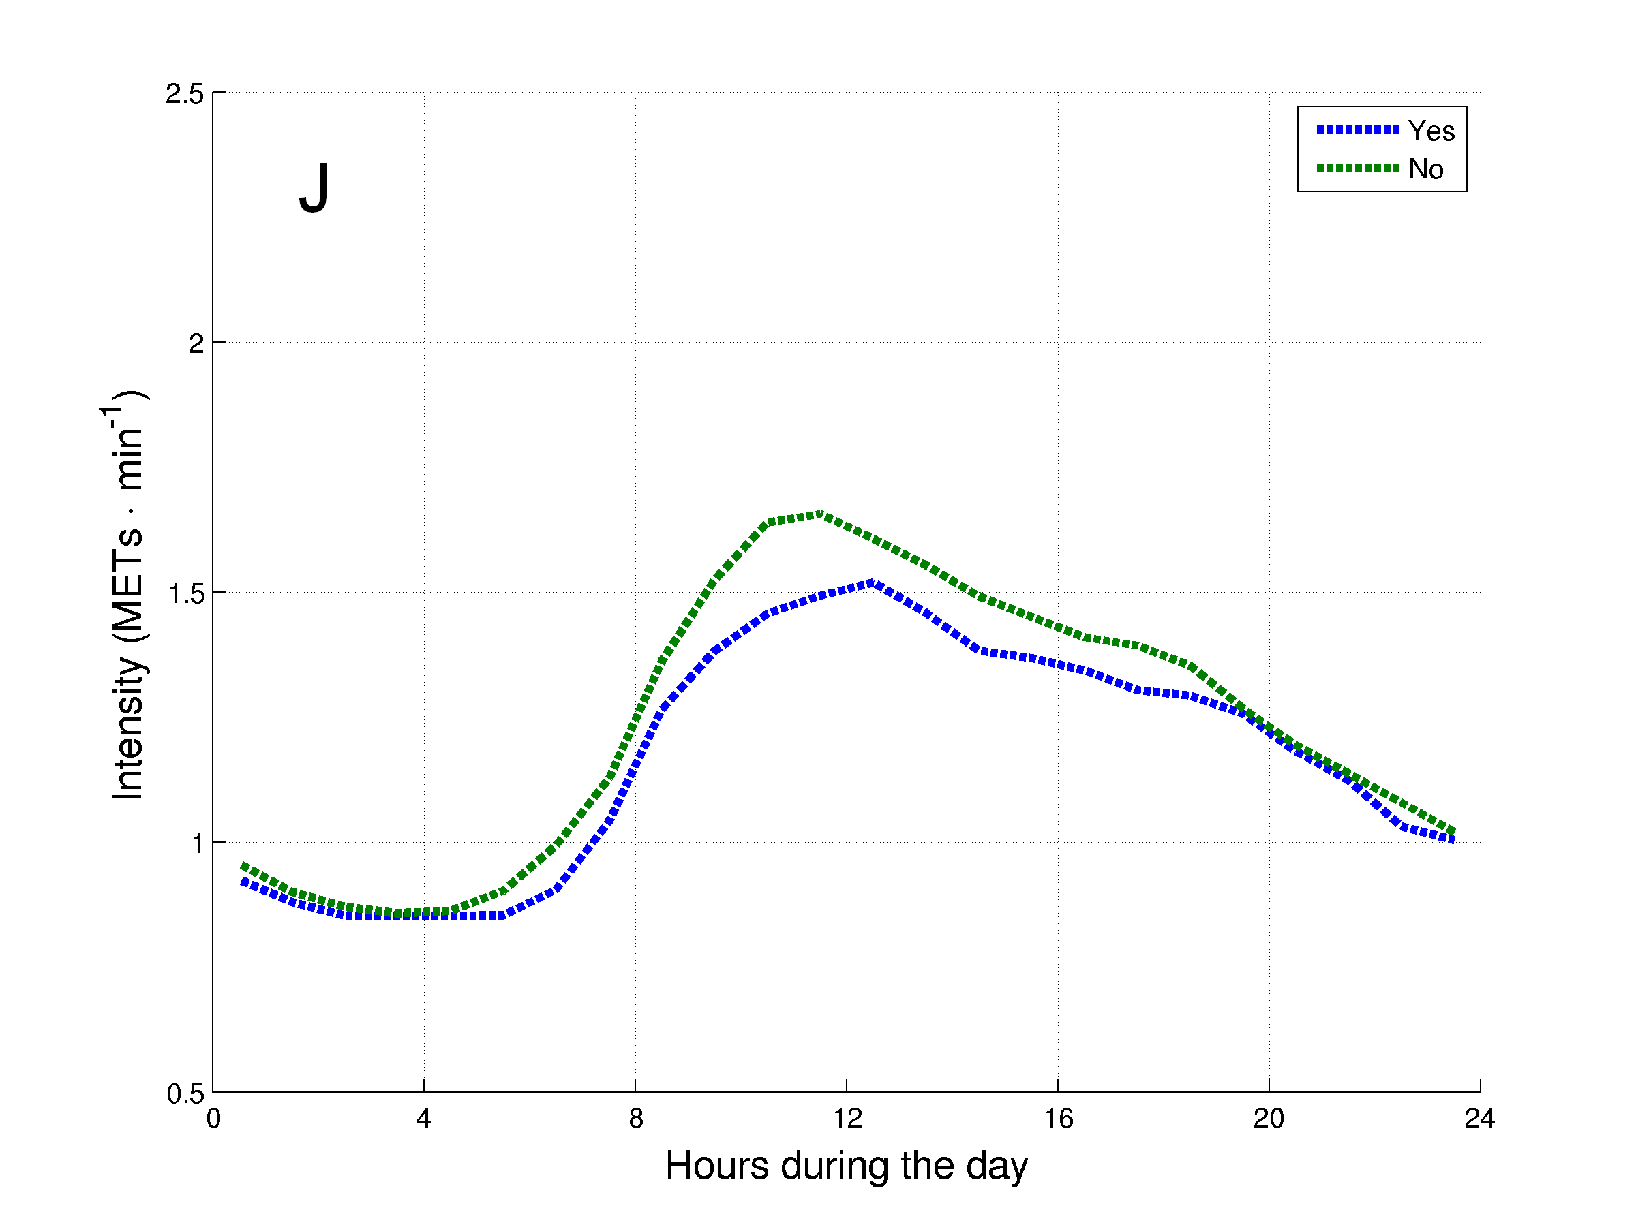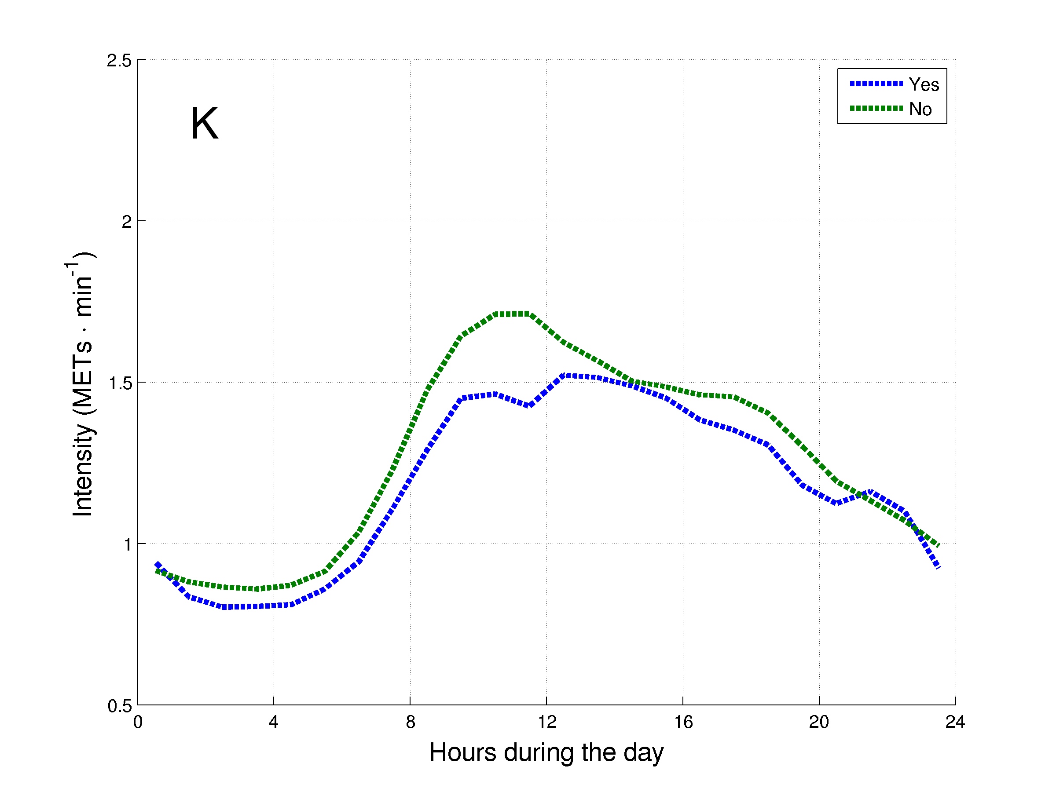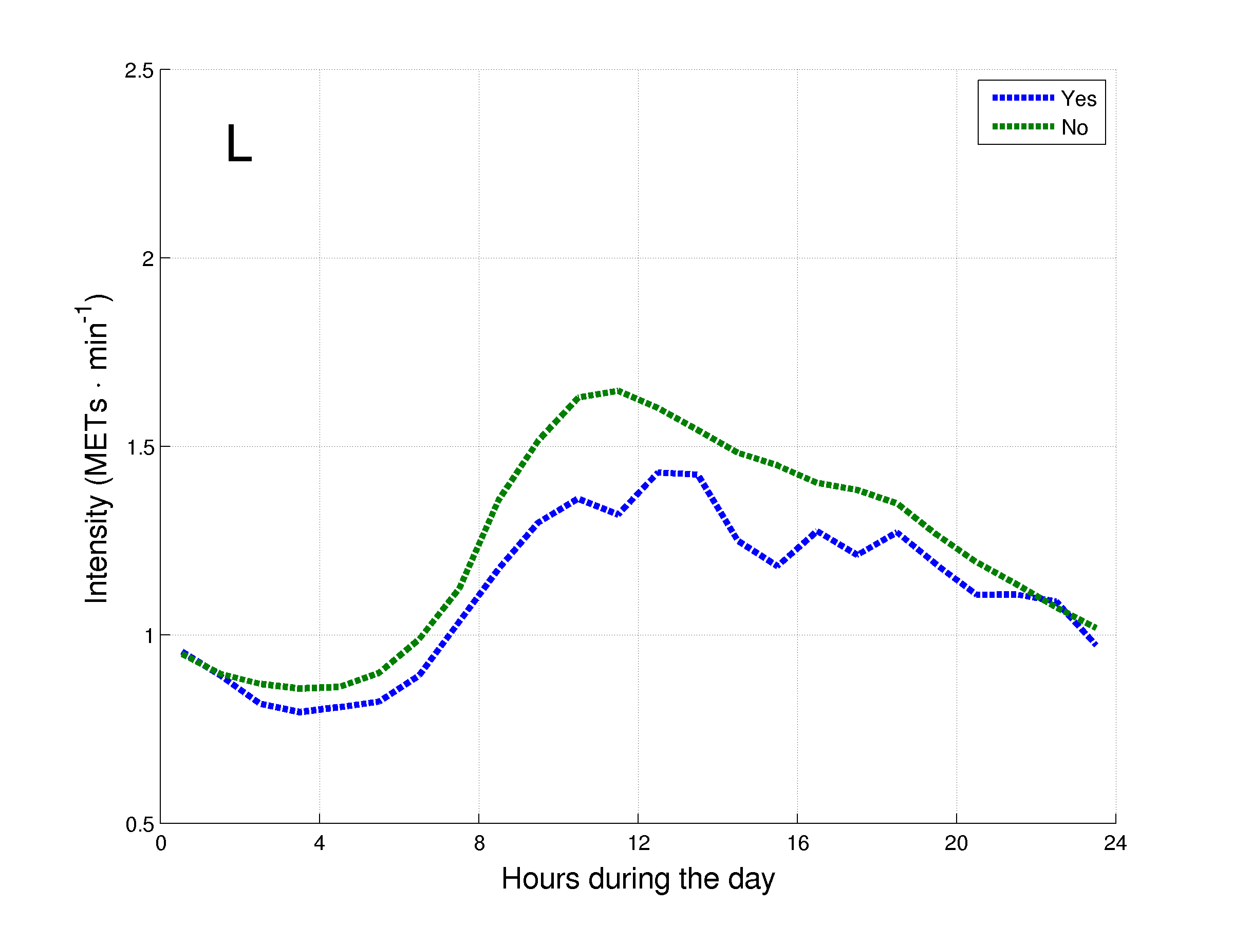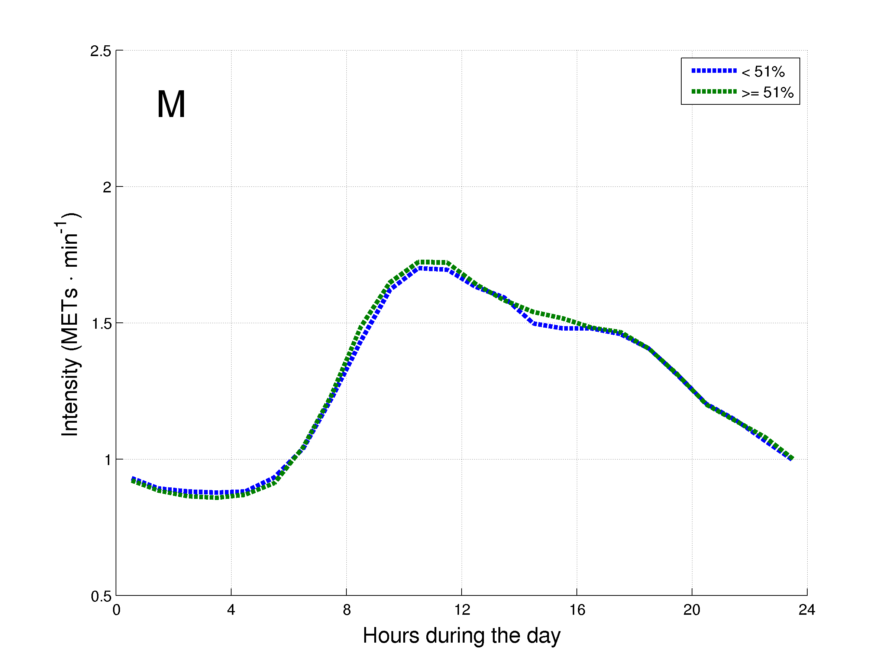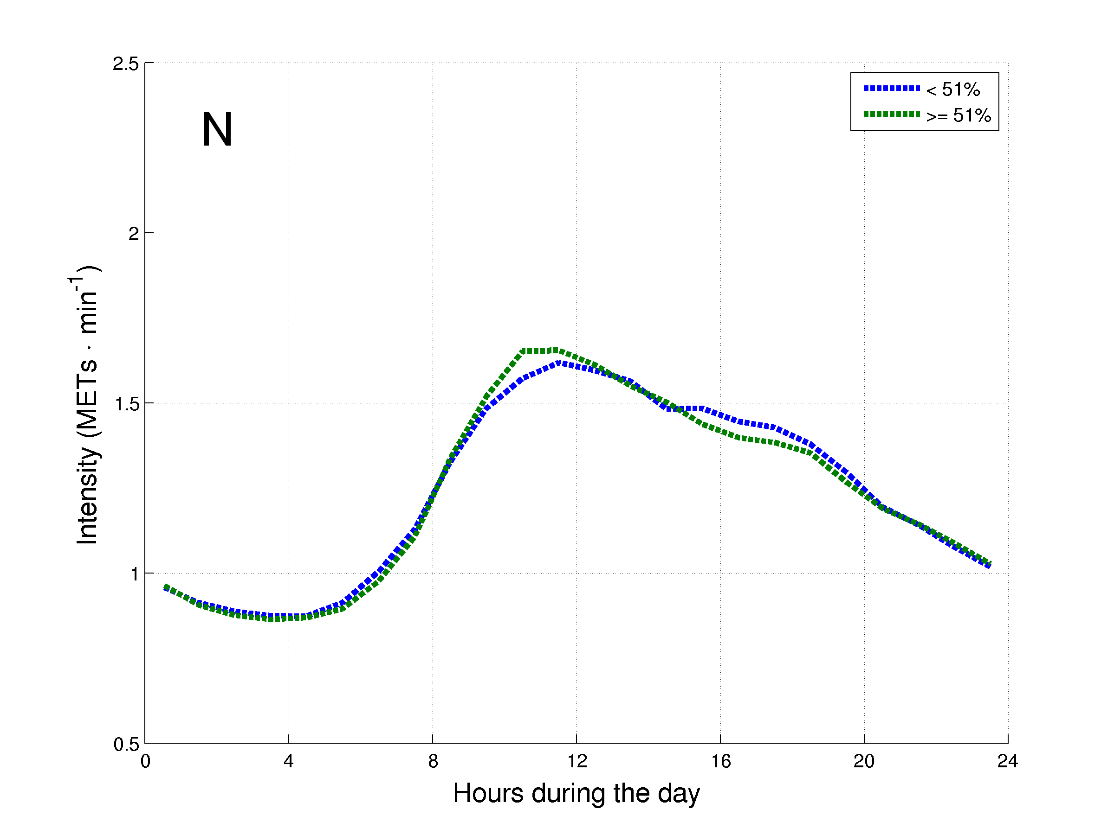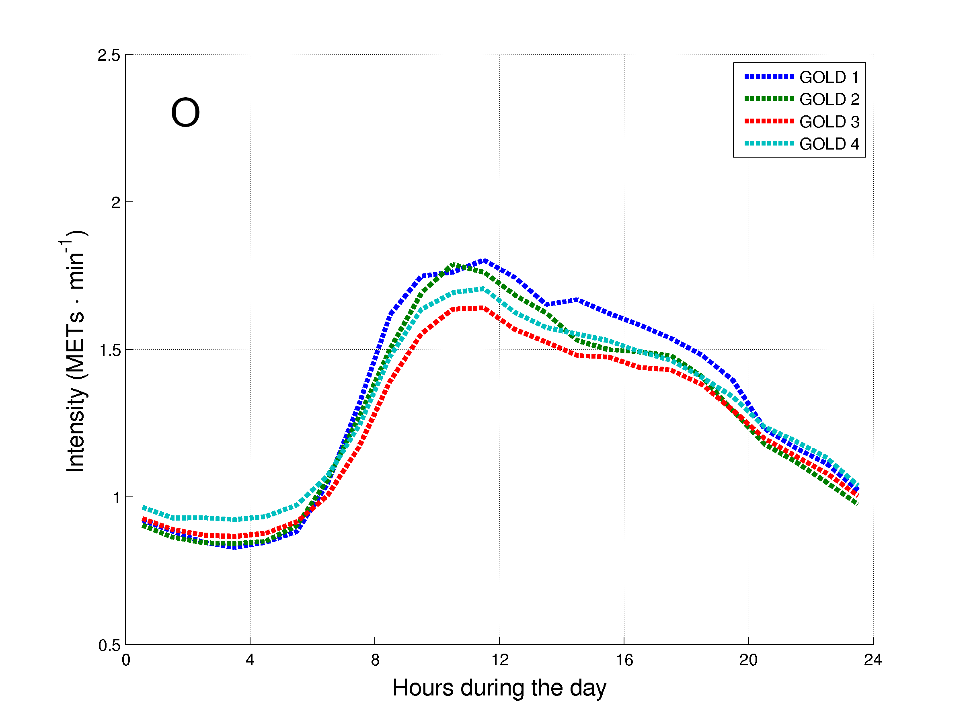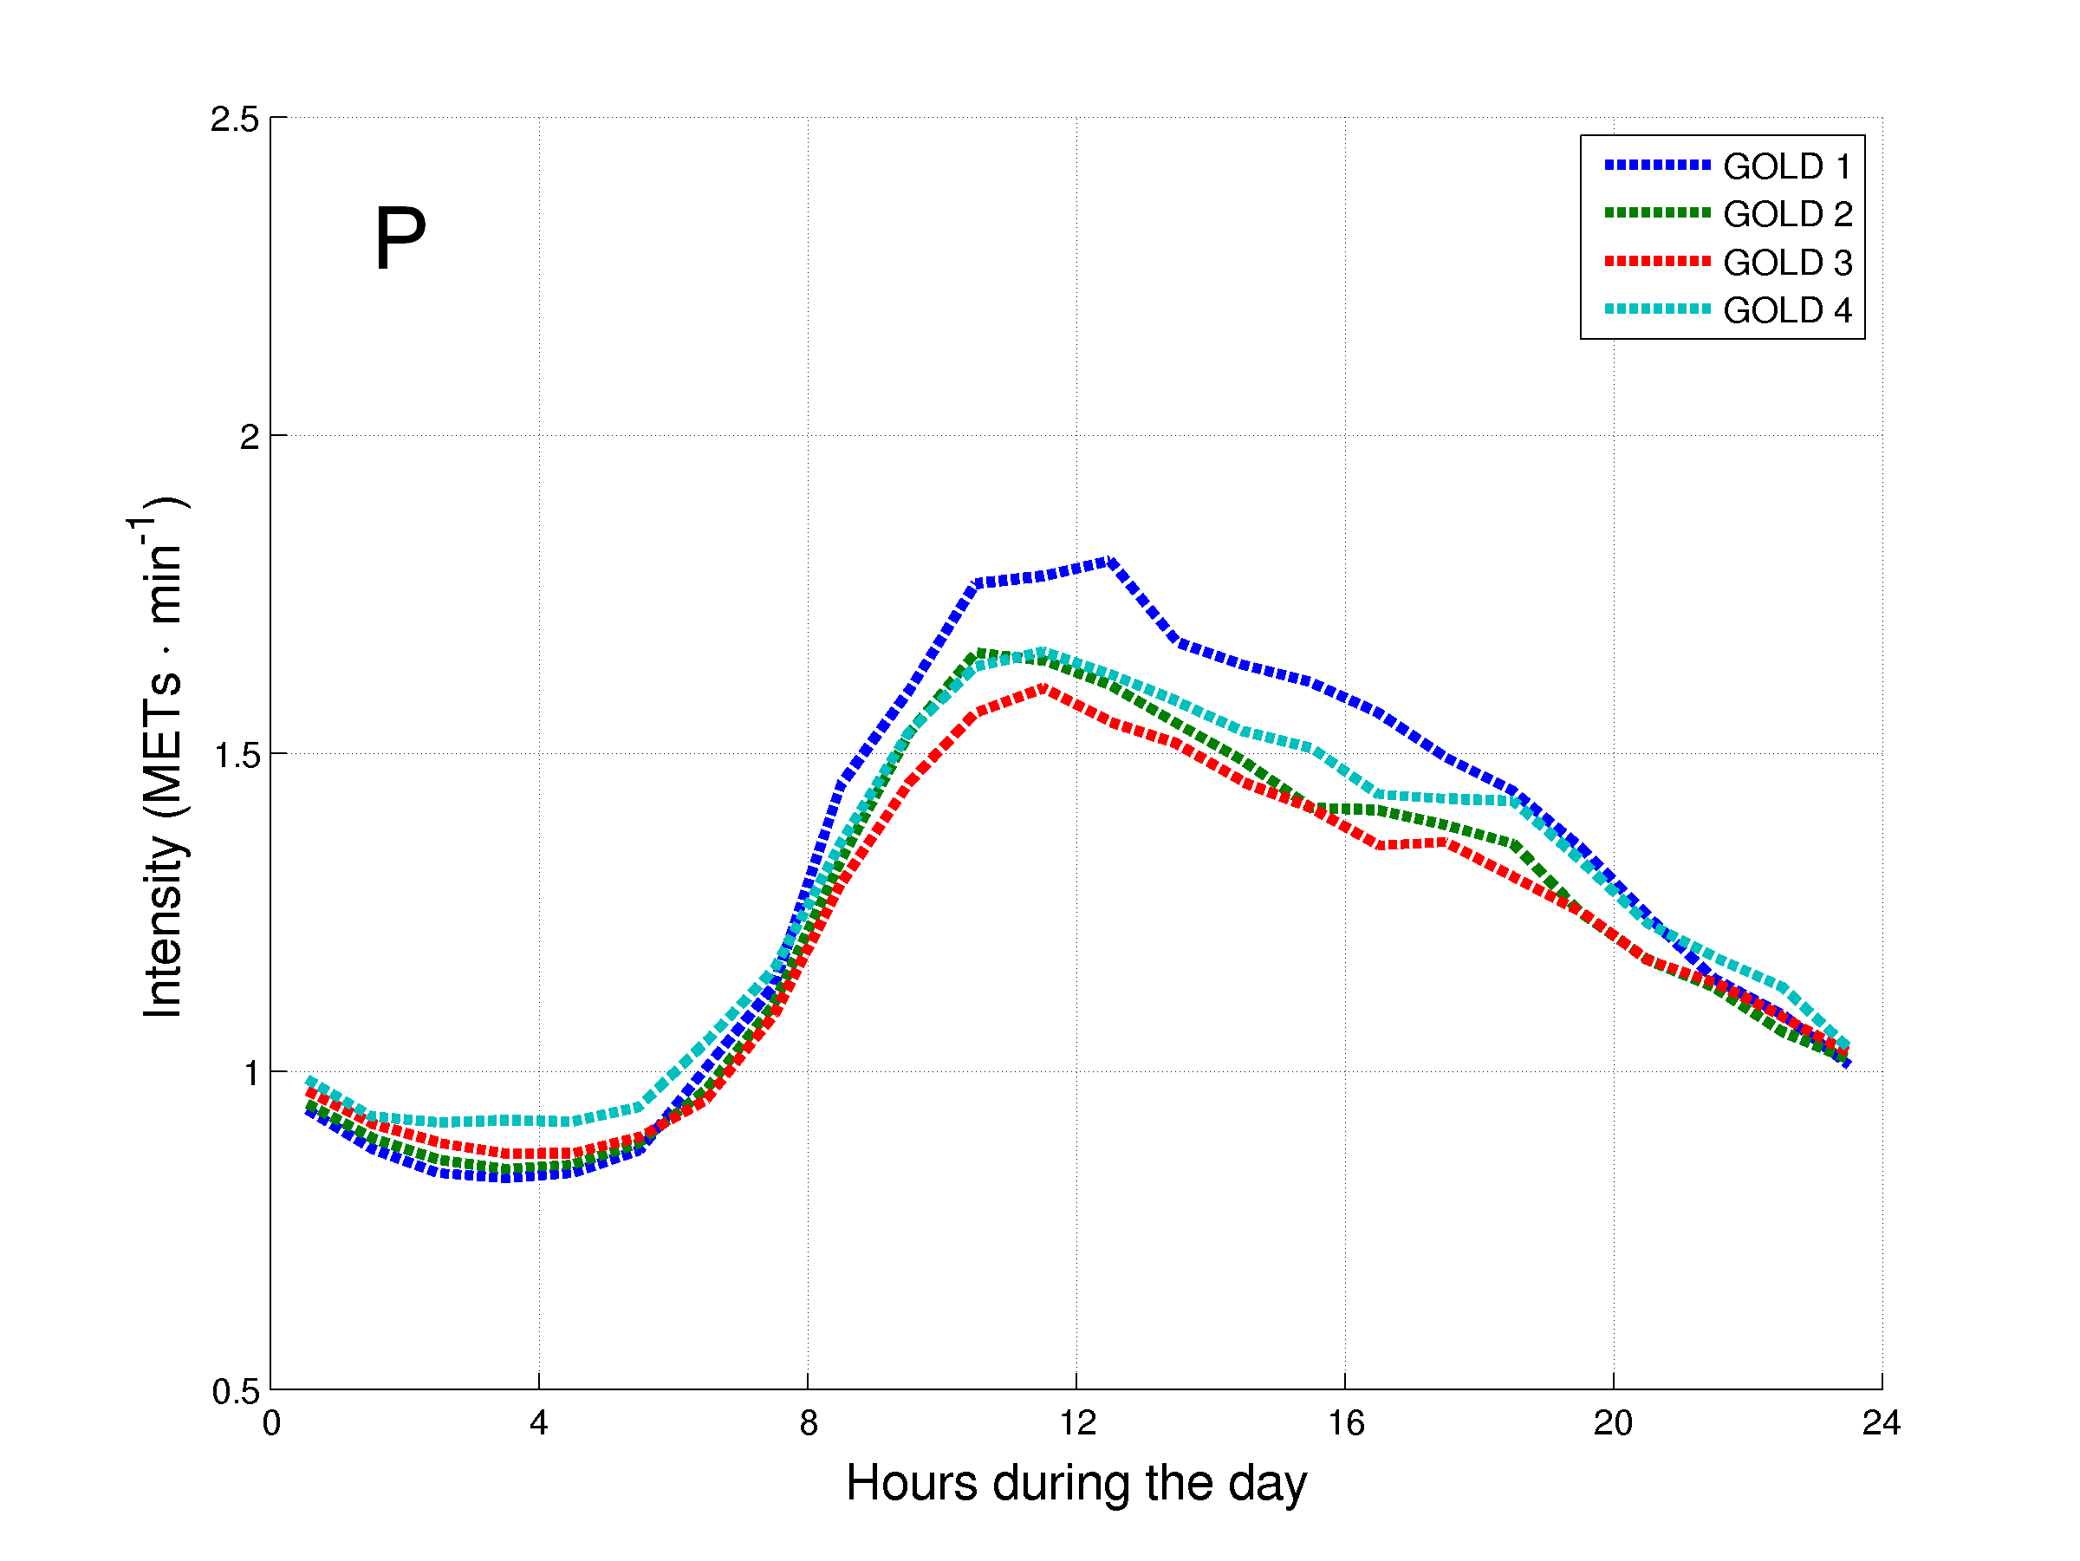
Figure 1. Daily hourly pattern of the patients with COPD after stratification for general characteristics during week (A, C, E, G, I, K, M and O) and weekend (B, D, F, H, J, L, N and P) days. The daily hourly pattern was stratified for: A and B – age groups; C and D – gender; E and F – body mass index (BMI) classification; G and H – modified Medical Research Council (mMRC) grades; I and J – long-term oxygen therapy (LTOT) use; K and L – walking aids use; M and N – diffusion capacity of the lung for carbon monoxide (DLCO) groups; and O and P – Global Initiative for Chronic Obstructive Lung Disease (GOLD) grades.
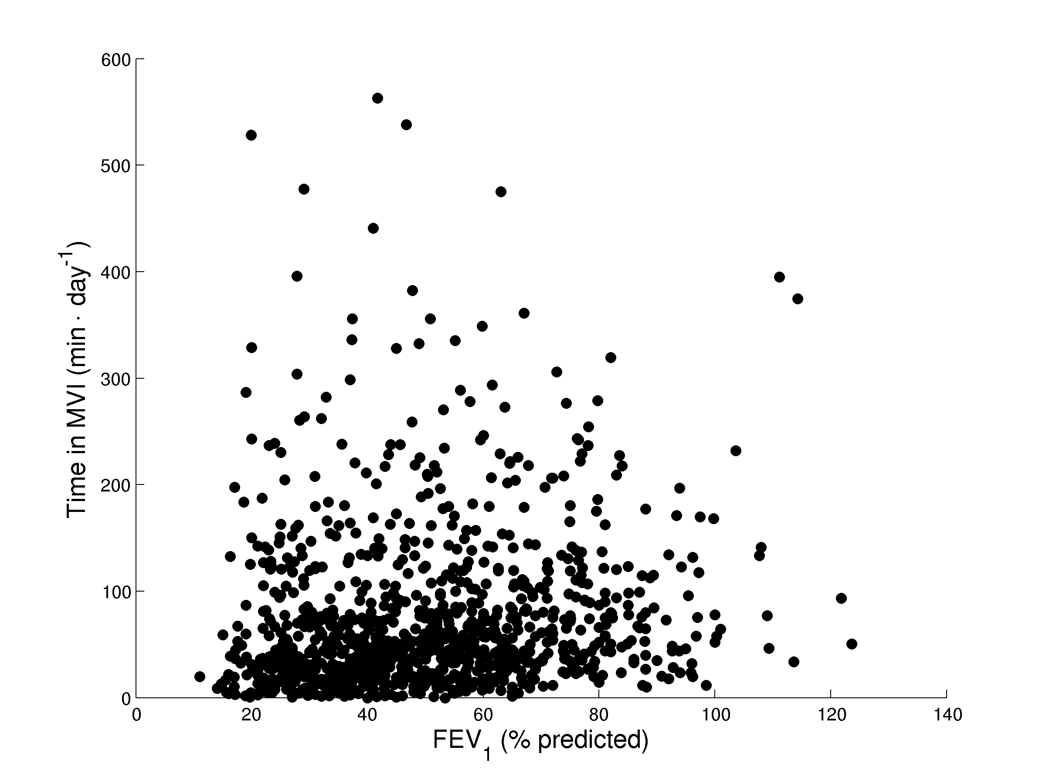
Figure 2. Correlation between the degree of airflow limitation and the daily time in MVI.

COPD versus healthy subjects
Table 3 presents the comparison of general characteristics and PA daily levels in MVI between healthy subjects and a group of matched patients with COPD. In total, 66 healthy subjects fulfilled all inclusion criteria and were included. Subjects with COPD presented worse lung function and dyspnea, as expected, but also worse levels of PA. The comparison of PA daily levels in VLI and LI can be found in Table E11 (online supplement). Interestingly, subjects with COPD spent more time in VLI than healthy subjects, but there was no difference for the time in LI. Figure 2 presents the daily hourly pattern of the groups during week and weekend days. Both groups presented the highest intensity in the morning. The hourly pattern during week and weekend days was similar in the COPD sample, but in the sample of healthy subjects the highest intensity achieved during the day was higher in the week compared to the weekend.

TABLE 3. GENERAL CHARACTERISTICS AND DAILY LEVELS OF PHYSICAL ACTIVITY IN MODERATE-TO-VIGOROUS INTENSITY IN HEALTHY SUBJECTS AND MATCHED PATIENTS WITH COPD
Variable | Healthy subjects | Matched patients with COPD | P-value
General characteristics  N | 66 | 66
Age, yrs | 65 (61 – 70) | 65 (61 – 70) | 1.00
Male, % | 45 | 45 | 1.00
BMI, kg·m⁻² | 25.3 (22.9 – 28.1) | 24.9 (22.4 – 27.9) | 0.65
FEV₁, % predicted | 107 (97 – 117) | 43 (29 – 63) | <0.0001
FEV₁/FVC, % | 78 (75 – 82) | 42 (32 – 54) | <0.0001
mMRC dyspnea grade, points* | 0 (0 – 0) | 2 (1 – 3) | <0.0001
Physical activity levels in MVI  Time, min∙day⁻¹ | 101 (57 – 163) | 47 (30 – 95) | <0.0001
EE, METs-min∙day⁻¹ | 461 (271 – 797) | 213 (123 – 435) | <0.0001
Time in ≥2-min bouts, min∙day⁻¹ | 82 (38 – 138) | 37 (15 – 83) | <0.0001
Time in ≥10-min bouts, min∙day⁻¹ | 29 (10 – 73) | 6 (0 – 20) | <0.0001
Frequency of ≥2-min bouts, bouts∙day⁻¹ | 17 (10 – 25) | 9 (5 – 17) | <0.0001
Frequency of ≥10-min bouts, bouts∙day⁻¹ | 2 (1 – 4) | 0 (0 – 1) | <0.0001
Average duration of ≥2-min bouts, min∙bout⁻¹ | 5 (4 – 7) | 4 (3 – 5) | <0.0001
Average duration of ≥10-min bouts, min∙bout⁻¹ | 16 (13 – 21) | 12 (0 – 14) | <0.0001
EE in ≥2-min bouts, METs-min∙day⁻¹ | 362 (212 – 712) | 164 (65 – 376) | <0.0001
EE in ≥10-min bouts, METs-min∙day⁻¹ | 107 (47 – 417) | 23 (0 – 121) | <0.0001
Data expressed as median (interquartile range). See Table 2 for definition of abbreviations. *Data missing for 18 healthy subjects and 7 patients with COPD.
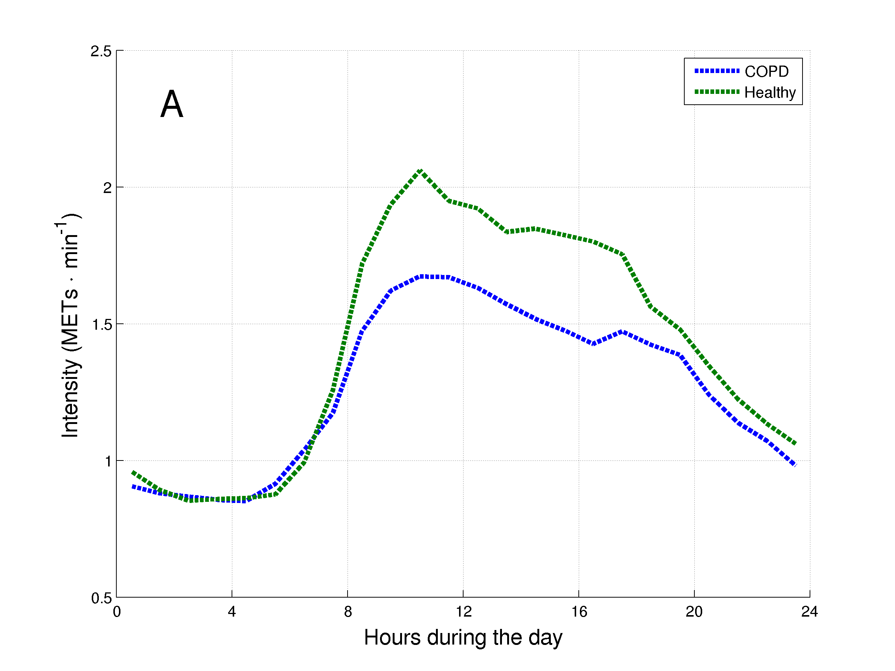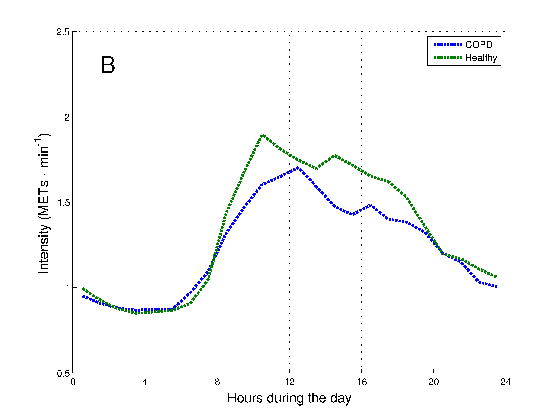
Figure 2. Daily hourly pattern of healthy subjects and matched patients with COPD during week (A) and weekend (B) days.

Cluster analysis of daily levels of physical activity
Five clusters were identified based on components from the PCA (Figure 3). The most relevant variables of each component can be found in the online supplement, as well as Figure 3 presented as a video. Table 4 presents the general characteristics and PA daily levels in MVI of the clusters identified. Cluster 2 presented a lower age compared to clusters 1 and 4, while cluster 1 presented a higher BMI than the other clusters and a lower FEV₁ than clusters 2 and 3. Regarding daily levels of PA, it can be roughly stated that cluster 1 was the least active and cluster 5 the most active cluster. The levels of PA in VLI and LI can be found in Table E12 (online supplement).

The hourly pattern of the clusters during week and weekend days can be found in Figure 4. In all clusters the highest intensity during the day occurred in the morning. In general, the hourly pattern during week and weekend days was similar, but the highest intensity during the day tended to be lower during the weekend. This phenomenon was more pronounced in Cluster 5 and less pronounced in Cluster 1.

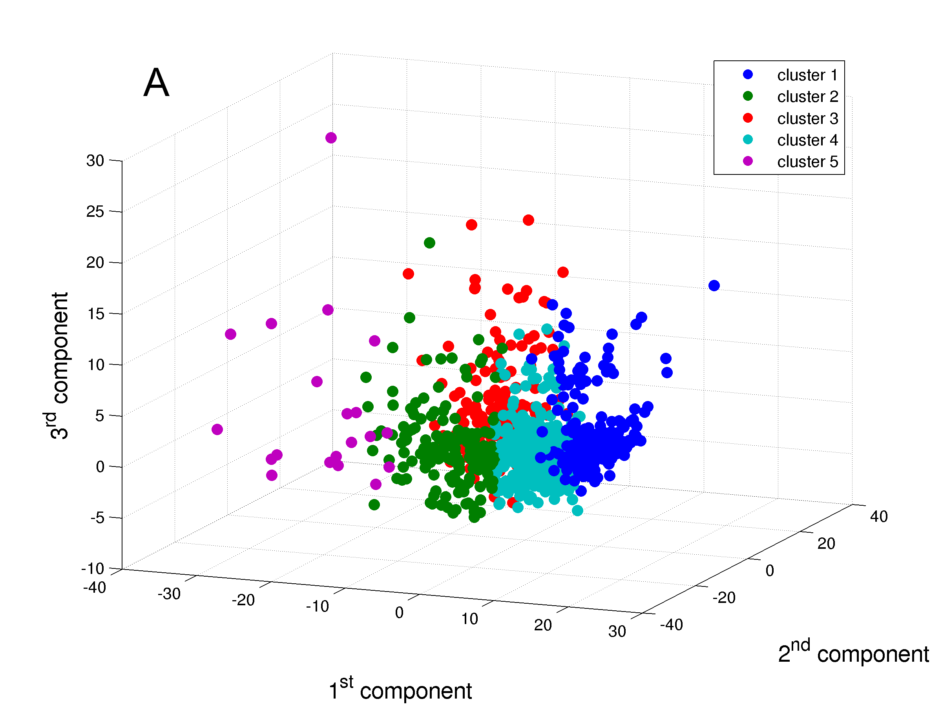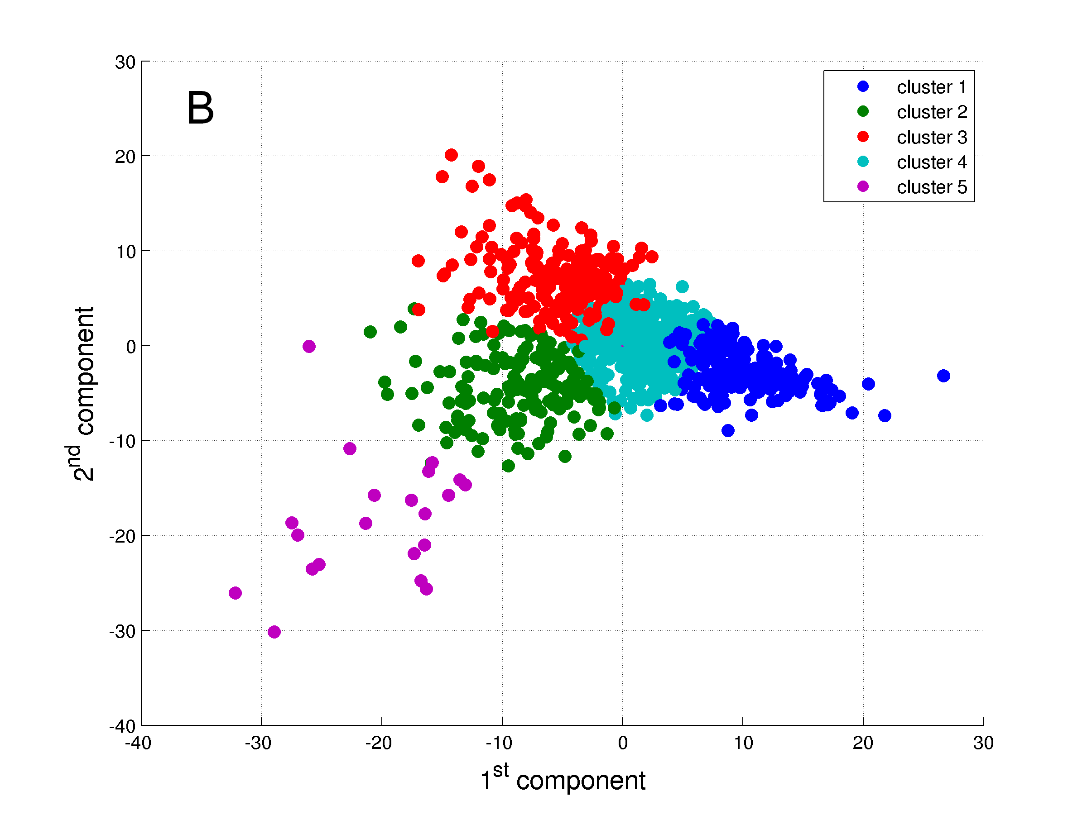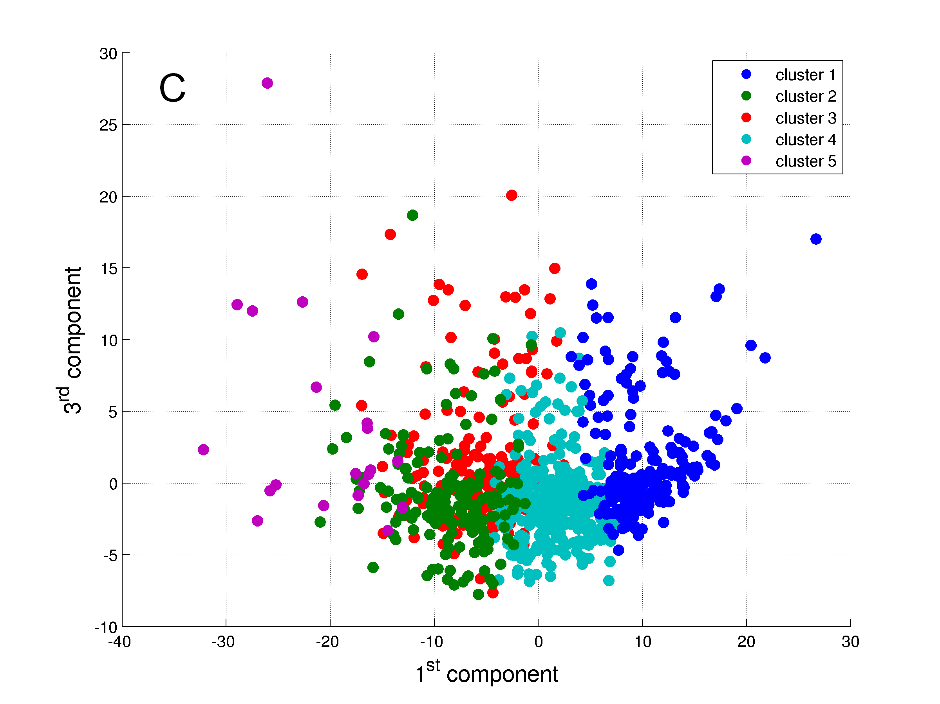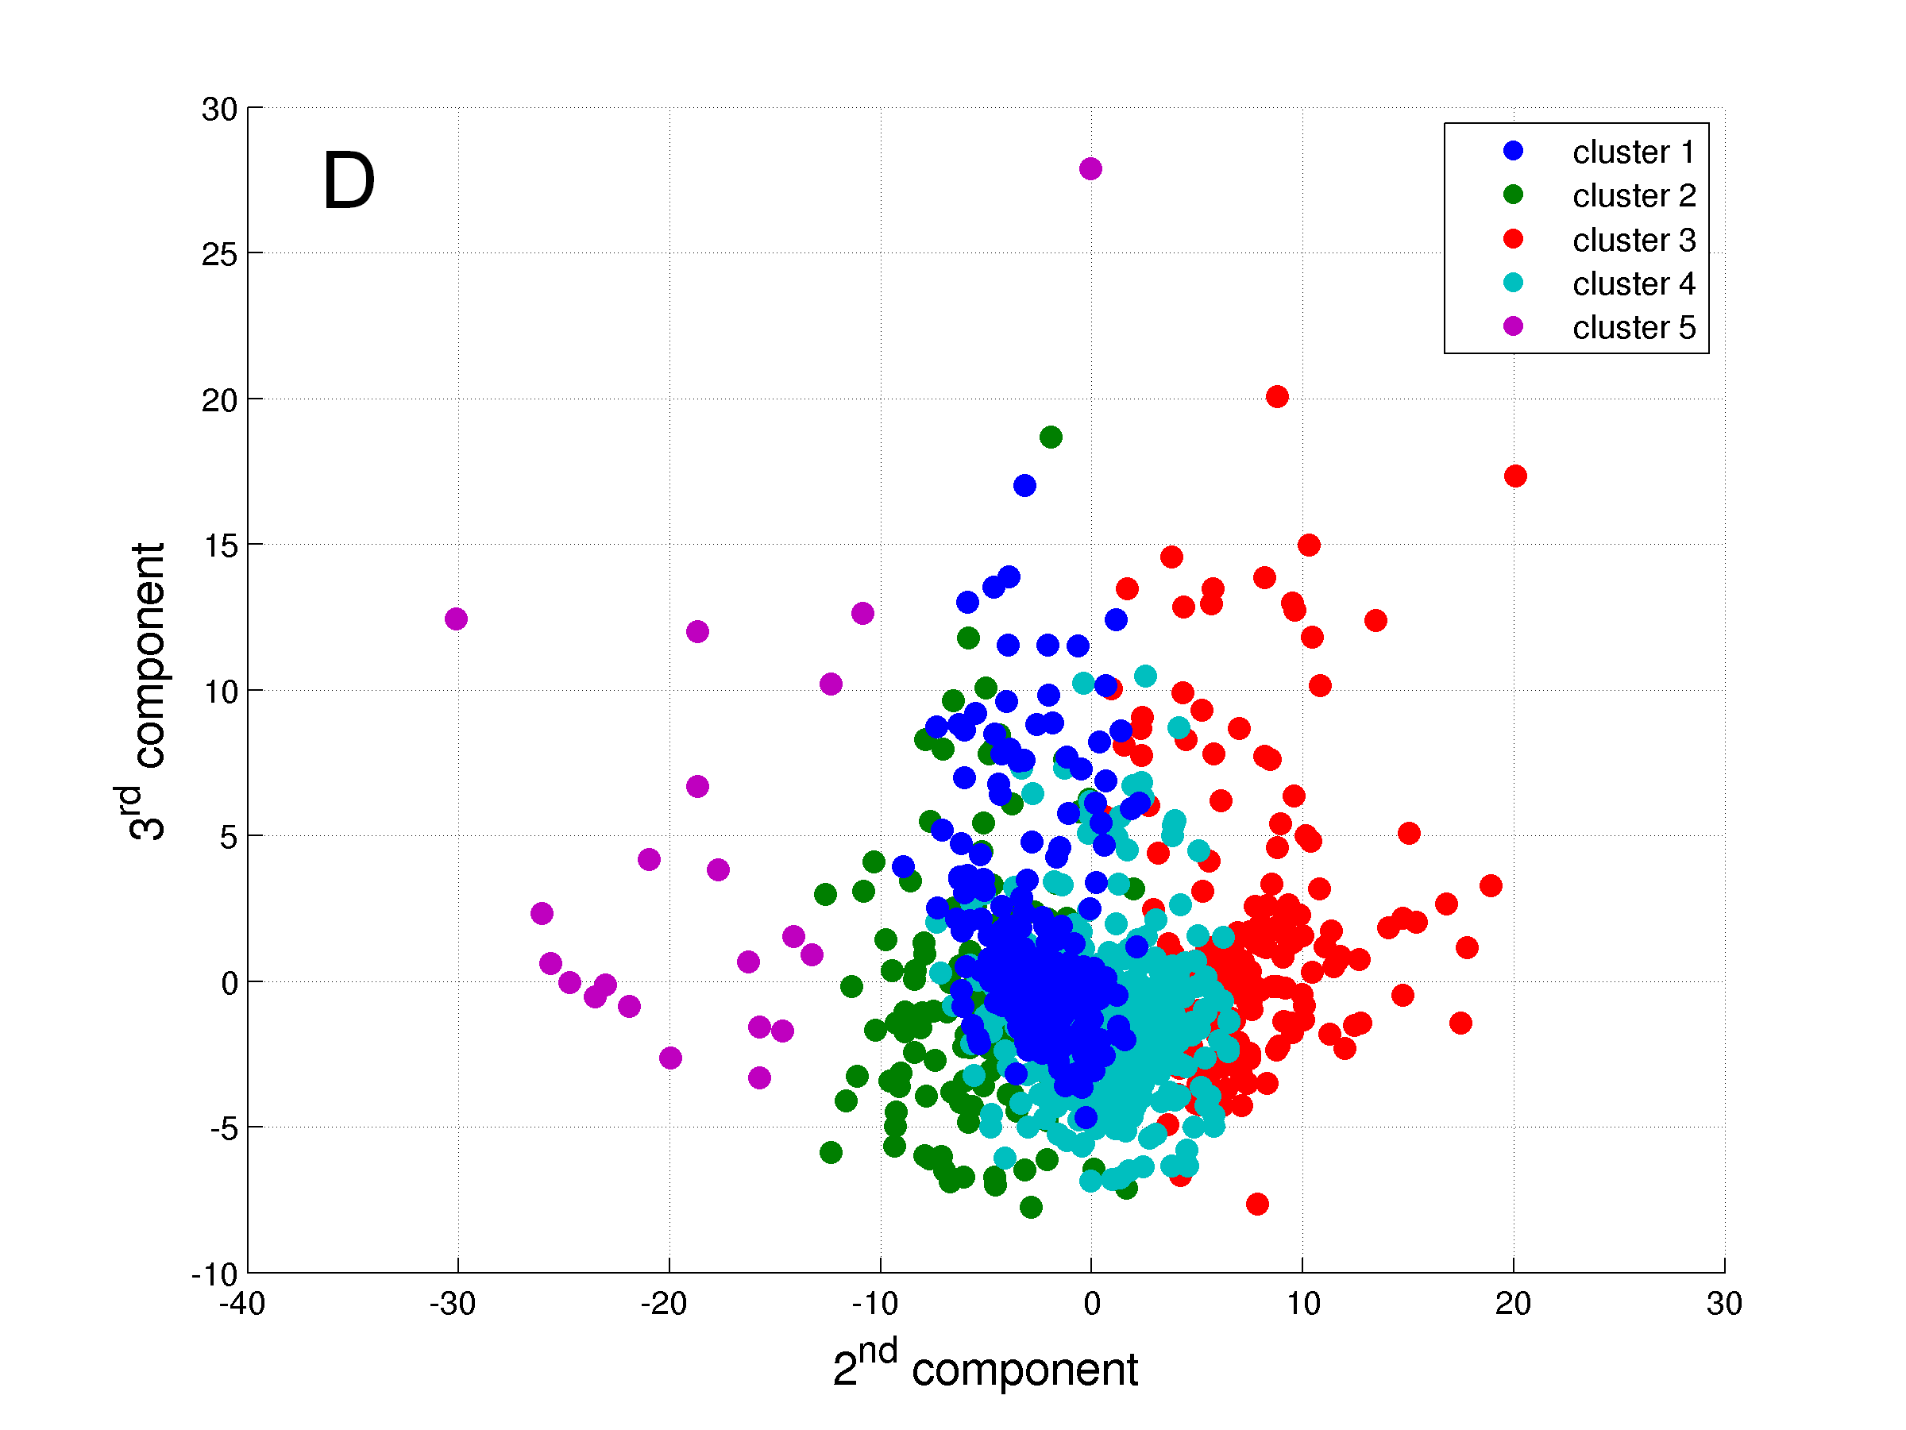
Figure 3. The five clusters identified. A: Graph in 3 dimensions presenting axes X, Y and Z; B: Graph in 2 dimensions presenting axes X and Y; C: Graph in 2 dimensions presenting axes X and Z; and D: Graph in 2 dimensions presenting axes Y and Z.
TABLE 4. GENERAL CHARACTERISTICS AND DAILY LEVELS OF PHYSICAL ACTIVITY IN MODERATE-TO-VIGOROUS INTENSITY OF THE CLUSTERS OF PATIENTS WITH COPD
Variable | Cluster 1 | Cluster 2 | Cluster 3 | Cluster 4 | Cluster 5 | P-value
General characteristics  N | 216 | 165 | 184 | 415 | 21
Age, yrs | 68 (62 – 74) | 63 (58 – 70)† | 67 (60 – 72) | 67 (61 – 72)‡ | 63 (56 – 68) | <0.0001
Male, % | 67 | 76 | 51 | 67 | 67 | 0.32
BMI, kg·m⁻² | 30.4 (26.5 – 34.7) | 23.1 (20.3 – 26.8)† | 24.9 (22.2 – 27.4)† | 25.7 (22.6 – 29.0)†,‡ | 22.5 (18.3 – 30.9)† | <0.0001
FEV₁, % predicted | 44 (32 – 58) | 50 (36 – 68)† | 57 (41 – 71)† | 48 (34 – 61)§ | 51 (39 – 70) | <0.0001
FEV₁/FVC, % | 43 (34 – 55) | 47 (36 – 57) | 50 (38 – 61)† | 44 (34 – 55)§ | 49 (38 – 64) | 0.002
mMRC dyspnea grade, points* | 2 (1 – 3) | 1 (0 – 3) | 1 (1 – 2) | 2 (1 – 3) | 1 (0 – 2) | <0.0001
Physical activity levels in MVI  Time, min∙day⁻¹ | 15 (7 – 27) | 166 (136 – 219)† | 68 (43 – 96)†,‡ | 48 (30 – 70)†,‡,§ | 361 (332 – 458)^{†,§,ǁ} | <0.0001
EE, METs-min∙day⁻¹ | 90 (40 – 192) | 805 (616 – 1134)† | 327 (198 – 527)†,‡ | 235 (138 – 349)†,‡,§ | 2693 (1694 – 5886)^{†,§,ǁ} | <0.0001
Time in ≥2-min bouts, min∙day⁻¹ | 9 (4 – 19) | 145 (118 – 190)† | 51 (29 – 72)†,‡ | 36 (20 – 54)†,‡,§ | 336 (293 – 433)^{†,§,ǁ} | <0.0001
Time in ≥10-min bouts, min∙day⁻¹ | 0 (0 – 3) | 60 (38 – 91)† | 9 (3 – 18)†,‡ | 5 (0 – 14)†,‡,§ | 209 (161 – 317)^{†,§,ǁ} | <0.0001
Frequency of ≥2-min bouts, bouts∙day⁻¹ | 3 (1 – 5) | 26 (20 – 33)† | 13 (8 – 17)†,‡ | 9 (6 – 13)†,‡,§ | 41 (35 – 52)^{†,§,ǁ} | <0.0001
Frequency of ≥10-min bouts, bouts∙day⁻¹ | 0 (0 – 0) | 3 (2 – 5)† | 1 (0 – 1)†,‡ | 0 (0 – 1)†,‡,§ | 10 (8 – 13)^{†,§,ǁ} | <0.0001
Average duration of ≥2-min bouts, min∙bout⁻¹ | 3 (2 – 4) | 6 (5 – 7)† | 4 (3 – 5)†,‡ | 4 (3 – 5)†,‡ | 8 (7 – 11)^{†,§,ǁ} | <0.0001
Average duration of ≥10-min bouts, min∙bout⁻¹ | 0 (0 – 11) | 17 (15 – 21)† | 13 (10 – 16)†,‡ | 12 (0 – 14)†,‡,§ | 20 (17 – 25)^{†,§,ǁ} | <0.0001
EE in ≥2-min bouts, METs-min∙day⁻¹ | 56 (20 – 123) | 704 (544 – 992)† | 251 (146 – 392)†,‡ | 173 (92 – 280)†,‡,§ | 2583 (1589 – 5348)^{†,§,ǁ} | <0.0001
EE in ≥10-min bouts, METs-min∙day⁻¹ | 0 (0 – 20) | 300 (171 – 513)† | 47 (13 – 105)†,‡ | 25 (0 – 70)†,‡,§ | 1635 (1102 – 2590)^{†,§,ǁ} | <0.0001
Data expressed as median (interquartile range). See Table 2 for definition of abbreviations. *Data missing for 18 subjects in Cluster 1, 39 subjects in Cluster 2, 25 subjects in Cluster 3, 48 subjects in Cluster 4, and 3 subjects in Cluster 5. PR; †P<0.05 vs Cluster 1; ‡P<0.05 vs Cluster 2; §P<0.05 vs Cluster 3; ^{ǁ}P<0.05 vs Cluster 4.
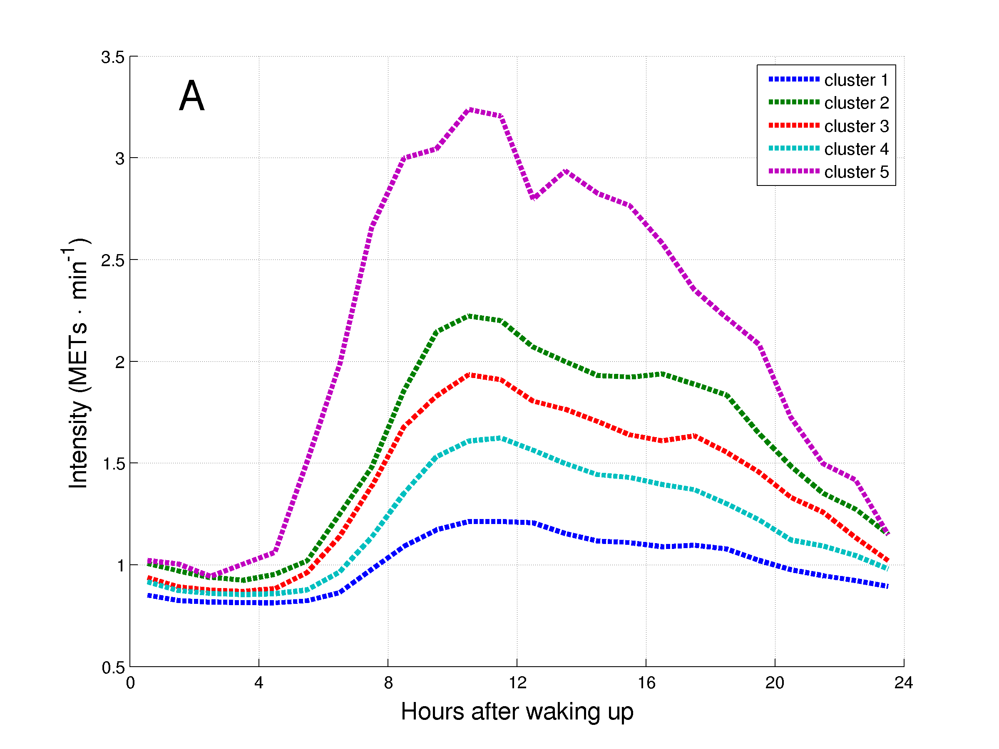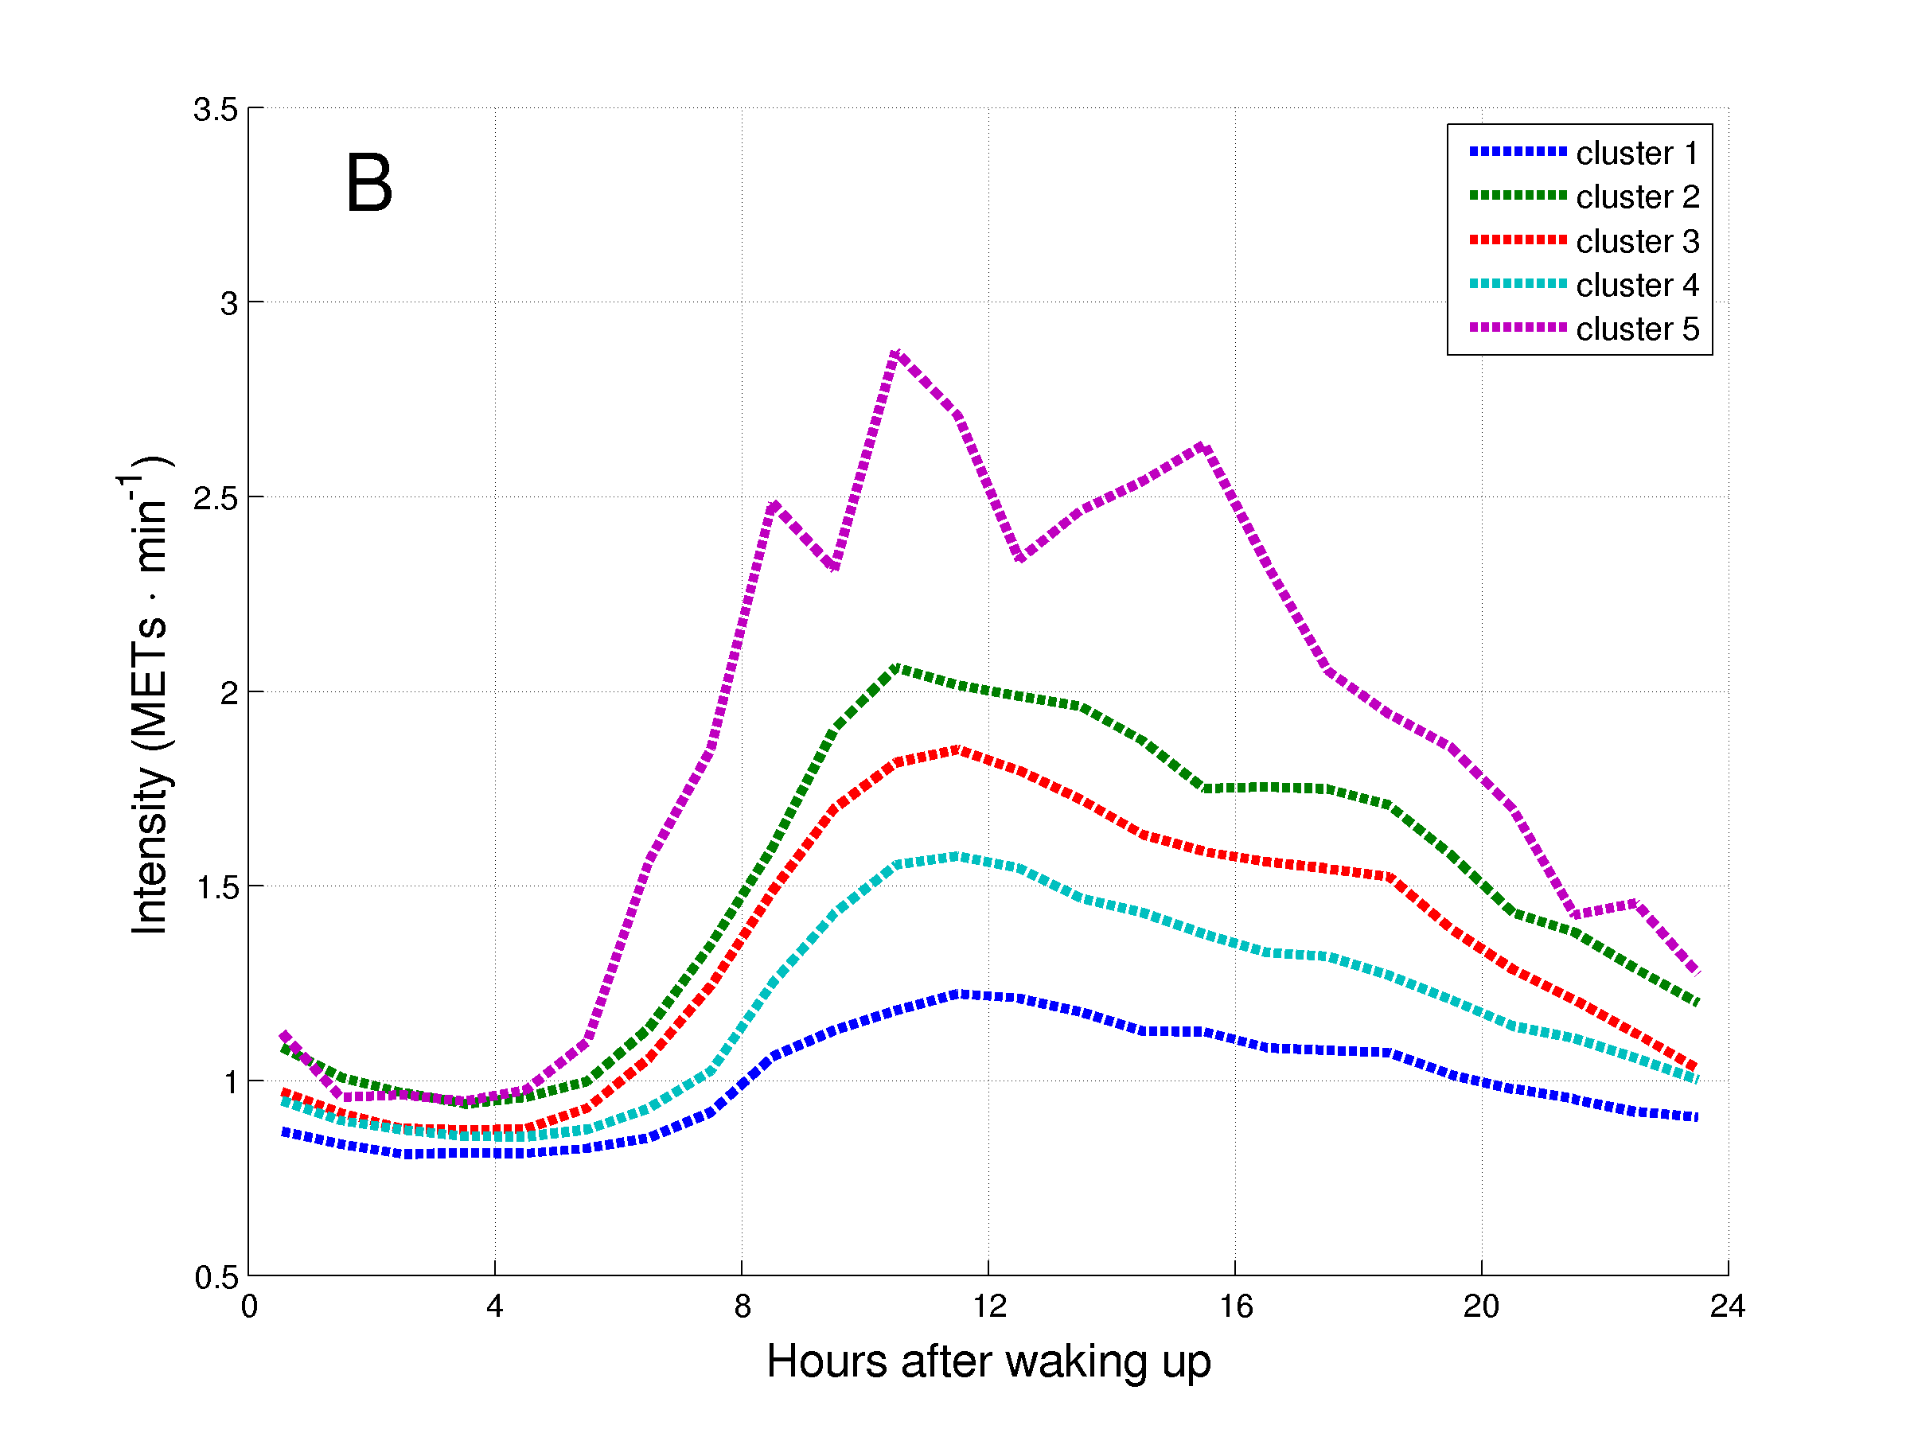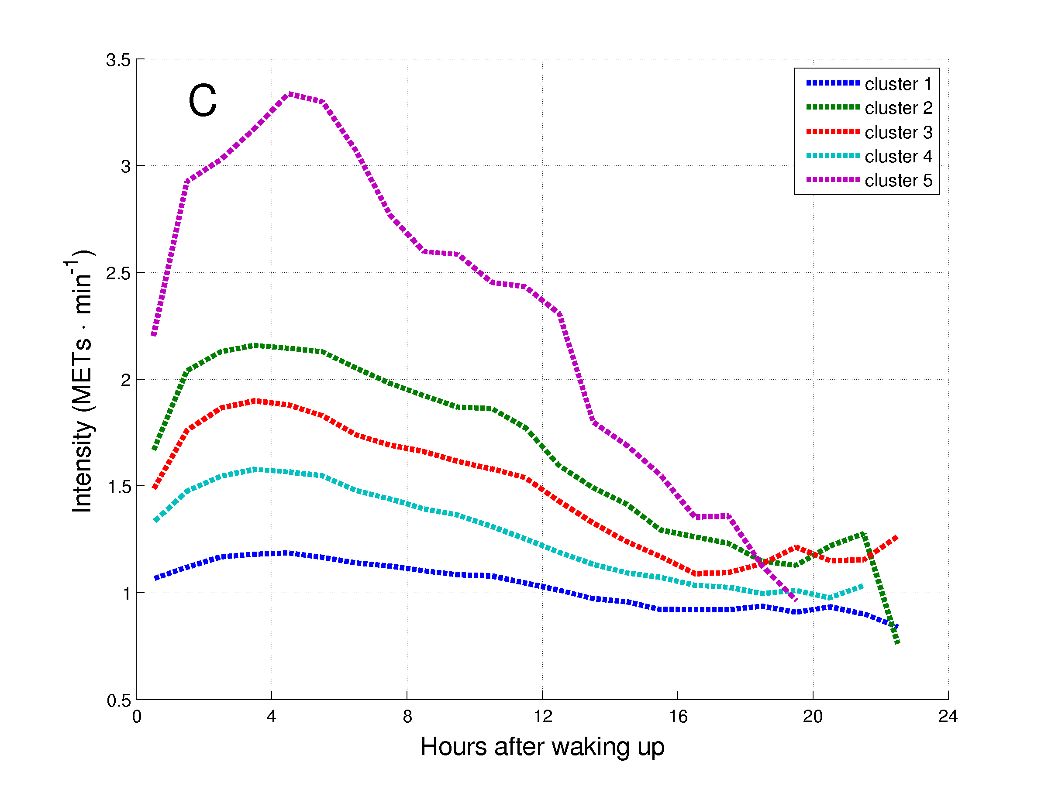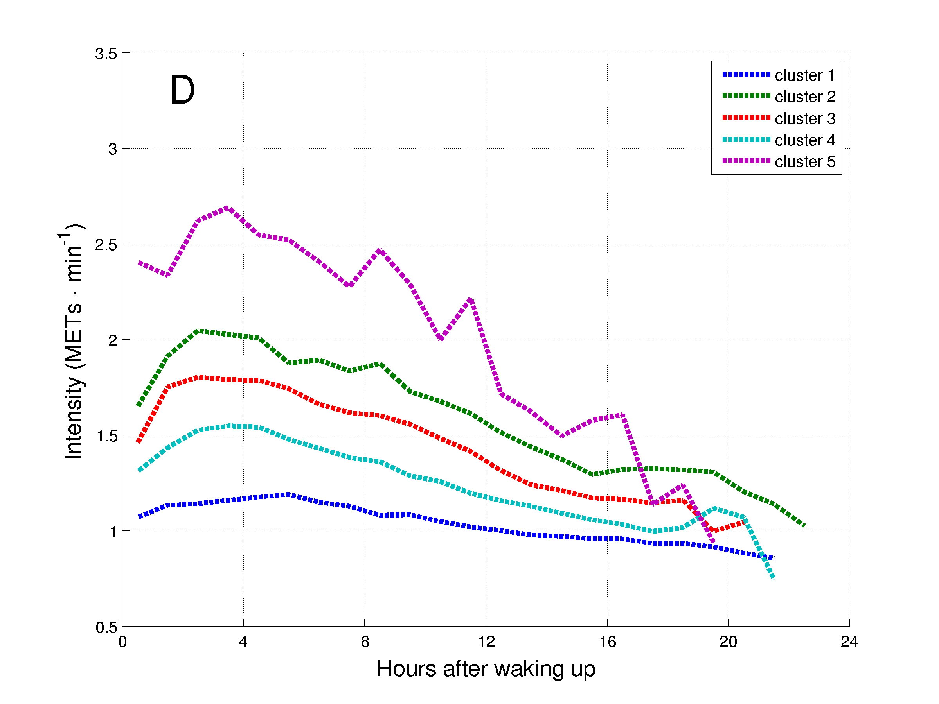
Figure 4. Daily hourly pattern of the clusters of patients with COPD during week (A and C) and weekend (B and D) days, and before (A and B) and after (C and D) synchronization of the waking up moment.

DISCUSSION

We have shown detailed analyses of PA in a large and multicentric sample of patients with COPD. PA is a very heterogeneous outcome, with basic characteristics being able to reveal distinct levels and patterns of PA. Patients with COPD presented lower levels of PA compared to matched healthy subjects, but different PA patterns were also observed. Moreover, five clusters of patients were identified, with two clusters presenting extreme levels of PA, but in opposite directions.

Daily levels and patterns of physical activity and heterogeneity for possible confounders
Patients with COPD spent a median of 52 (26 – 99) min∙day⁻¹ in MVI, but this represents the sum of any minute above the threshold for MVI. When bouts of at least 10 minutes were considered, patients spent a median of 6 (0 – 22) min·day⁻¹ only, which is far below the recommended ≥30 min∙day⁻¹.REF Only two studies so far have investigated ≥10-minute bouts of MVI in COPD. The first study found a median time of 57 (20 – 106) min·day⁻¹, but this is probably a consequence of the lower threshold adopted for MVI (i.e., 2.6 METs).REFDonaire In the second study different thresholds were analyzed, but when the same threshold adopted in our study was considered, a more similar result is observed (i.e., 13 (2 – 35) min·day⁻¹).REFvanRemmortel Considering bouts of at least 2 minutes, we were able to show that the time in MVI is actually organized in bouts of 4 (3 – 5) minutes with a frequency of 10 (5 – 17) bouts·day⁻¹. These findings are important when planning activities for patients with COPD.

Our results clearly show that PA is a very heterogeneous outcome which associates with many other outcomes, corroborating previous findings.REF Distinct levels of PA were found according to age, gender, BMI, mMRC grade, LTOT, use of walking aids, DLCO, and GOLD grade, but only BMI, mMRC grade, and use of walking aids seem to importantly affect patterns of PA. The analysis of daily hourly patterns has revealed very interesting results. It can be observed, for instance, that the highest intensity achieved during the day occurred before midday, even after stratification. This suggests that patients are more active in the morning compared to the afternoon and evening. This is also supported by the fact that the time in MVI before and after midday is almost the same (Table 2), even with the period after midday being longer than the one before midday. Also from the hourly patterns it can be noticed that week and weekend days have a similar pattern, but the highest intensity during the day tended to be lower during the weekend.

Daily levels and patterns of physical activity in healthy subjects and patients with COPD
Although previous studies had already shown that patients with COPD are less active than healthy subjects,REF our study is the first to observe this finding in samples matched by gender, age and BMI, three known confounding factors of PA.REF Johnson-Warrington et al.REF have recently compared healthy subjects and patients with COPD with the same MRC grade (i.e., MRC grade 2) and observed that patients with COPD are less active even presenting the same degree of dyspnea. Once again, this finding and our results support that PA is a multidimensional outcome influenced by a variety of factors. Our study is probably the first to show that patients with COPD spent not only less time in MVI, but also more time in VLI, which can be assumed as a surrogate of sedentary time. One could argue that this could be expected, as in order to increase the time in one intensity the subjects need to reduce the time in another one. However, although this is true, previous studies have shown that some subjects can be considered active, but still present considerable amounts of time in very light intensities.REF Most previous studies have used only the time in MVI to evidence the inactivity of patients with COPD,REF and this can produce spurious results. Pate and colleaguesREF provide a deeper discussion on this matter. Our results confirm that patients with COPD are really inactive when compared to healthy subjects. The hourly patterns revealed that patients with COPD develop their activities in a lower intensity when compared to healthy subjects, but also that this difference is more pronounced during the week. Interestingly, healthy subjects also have the peak of intensity during the day before midday, as was found in the total sample of patients with COPD.

Clusters of patients with COPD based on daily levels of physical activity
Cluster analysis is an interesting option for the analysis of levels of PA, an outcome influenced by multiple factors, in patients with COPD, a heterogeneous disease. Cluster analysis analysis has its basis both in mathematics and biology, and aims to group subjects in a way that between-group differences will be maximized and within-group differences minimized.REFHan2010;Fingleton2011 It is a valuable analysis in studies like the one presented here.

Five clusters – and not phenotypes, as our results were not related to other clinically meaningful outcomes, such as survival,REFHan2010 were identified. Two clusters were identified in the two endpoints of the continuum of PA, cluster 1 was the most inactive cluster and cluster 5 the most active. Indeed, cluster 1 not only spent less time in MVI, but also more time in VLI, suggesting that the subjects from this cluster are truly inactive. Cluster 1 presented higher BMI, lower FEV₁ and older age, and these findings are probably linked to the inactivity presented by this cluster. However, we believe they are not the main causes, as previous studies have shown that these variables explain only in part the variance of levels of PA in COPD.REF As lower levels of PA are known contributors to greater morbidity and mortality,REFGarcia-Aymerich2006;Waschki2011 cluster 1 would probably benefit the most from interventions aiming to increase PA.

Only a few studies have employed cluster analysis using levels of objectively measured PA exclusively, but all in populations other than COPD.REFLee2013;De Bourdeaudhuij2013 On the other hand, a bigger number of studies have used cluster analysis in COPD, but none using levels of PA.REFBurgel2010;Garcia-Aymerich2011;Vanfleteren2013 Some similarities can be observed between our results and previous findings. Cluster 1 from our study, for instance, resembles group 1 in the study by Garcia-Aymerich et al.REF, while our cluster 5 shares some characteristics with cluster 1 from Vanfleteren et al.REF, referred as less comorbidity. Previous studies have suggested an association between comorbidities and levels of PA.REFWatz2008;Garcia-Aymerich2004 Further comparisons are compromised by the lack of other relevant variables in our study or measures of physical activity in previous studies with cluster analysis.

Regarding patterns of PA, we noticed that all cluster presented the highest intensity before midday, finding also observed in the total sample after stratification for different characteristics. We also observed that the more inactive a cluster is, the more similar is its hourly pattern of week and weekend days. In one of the few studies investigating hourly patterns of PA, Lee et al.REF observed a more regular pattern during week days, with some slight increases around 08.00-08.59, 13.00-13.59 and 18.00-18.59. In their study, however, a population of younger adults (mean age 43 years) was investigated, and these periods of increase probably represent times of commuting to and from work, and going to lunch. In our study, unfortunately, the proportion of subjects working is not known, but is probably less than the one in the study by Lee et al.REF During weekend, these authors observed a more irregular pattern, with the highest intensity occurring after midday. We believe that differences between the studies are probably due to different age of the groups, mainly.

Strengths and limitations of the findings
The total sample of patients with COPD is by far the largest sample of patients with COPD with objectively assessed PA ever studied. This allowed us to study in depth PA, even identifying clusters of subjects with similar PA levels, a true novelty within the COPD literature. The analysis of hourly patterns is also another novelty, and all these analyses were only possible due to the use of objective methods of PA, another strength in our study. Important results were found in our study, but further steps are necessary. First, a validation of the current results in a longitudinal study is crucial, both to check the relationship with changes in important outcomes, such as mortality, as to investigate the stability of the clusters over time. Second, future studies should try to identify clusters based on levels of PA, and maybe to propose a way of identifying to which cluster a subject comes from (e.g., an allocating algorithm).

Despite the strengths, some limitations can be underscored. First, subjects from different studies - which had different objectives and inclusion/exclusion criteria, were included in the current analysis, and this could be seen as a limitation. On the other hand, this also allowed us to have a more diverse, and maybe more representative, sample of patients with COPD. One could argue that variables other than levels of PA were not included in the cluster analysis. However, the inclusion of levels of PA only was intentional, to investigate if this outcome was able to identify groups with distinct characteristics. Nonetheless, a cluster analysis including other relevant outcomes might be interesting and provide different results.

This study has truly advanced the understanding of levels of physical activity in patients with COPD. This is the first study to show, in a large and multicentric sample of patients with COPD, that not only levels, but also patterns of physical activity, are distinct according to different basic characteristics. These levels and patterns are reduced in patients compared to matched healthy subjects. Moreover, five clusters of patients were identified based on levels of physical activity, and two of these clusters presented extreme levels of physical activity, but in opposite directions. The most inactive cluster seems to be a more common finding in COPD population and needs special attention. The findings of this study have important clinical implications, especially for interventions aiming to improve levels and patterns of physical activity in patients with COPD.
ACKNOWLEDGEMENTS

The authors would like to gratefully acknowledge all the subjects not included as co-authors in this study but that somehow helped with data collection in each centre. FOR CENTRES: Please add here your own acknowledgements, if there is any.
REFERENCES

1 Pitta F, Troosters T, Spruit MA, et al. Characteristics of physical activities in daily life in chronic obstructive pulmonary disease. Am J Respir Crit Care Med 2005; 171:972-977
2 Sandland CJ, Singh SJ, Curcio A, et al. A profile of daily activity in chronic obstructive pulmonary disease. J Cardiopulm Rehabil 2005; 25:181-183
3 Walker PP, Burnett A, Flavahan PW, et al. Lower limb activity and its determinants in COPD. Thorax 2008; 63:683-689
4 Garcia-Aymerich J, Lange P, Benet M, et al. Regular physical activity reduces hospital admission and mortality in chronic obstructive pulmonary disease: a population based cohort study. Thorax 2006; 61:772-778
5 Waschki B, Kirsten A, Holz O, et al. Physical activity is the strongest predictor of all-cause mortality in patients with COPD: a prospective cohort study. Chest 2011; 140:331-342
6 Bossenbroek L, de Greef MH, Wempe JB, et al. Daily physical activity in patients with chronic obstructive pulmonary disease: a systematic review. COPD 2011; 8:306-319
7 Pitta F, Troosters T, Probst VS, et al. Quantifying physical activity in daily life with questionnaires and motion sensors in COPD. Eur Respir J 2006; 27:1040-1055
8 van Poppel MN, Chinapaw MJ, Mokkink LB, et al. Physical activity questionnaires for adults: a systematic review of measurement properties. Sports Med 2010; 40:565-600
9 Watz H, Waschki B, Meyer T, et al. Physical activity in patients with COPD. Eur Respir J 2009; 33:262-272
10 Pitta F, Takaki MY, Oliveira NH, et al. Relationship between pulmonary function and physical activity in daily life in patients with COPD. Respir Med 2008; 102:1203-1207
11 Hill K, Dolmage TE, Woon L, et al. Defining the relationship between average daily energy expenditure and field-based walking tests and aerobic reserve in COPD. Chest 2012; 141:406-412
12 Depew ZS, Karpman C, Novotny PJ, et al. Correlations between gait speed, 6-minute walk distance, physical activity, and self-efficacy in patients with severe chronic lung disease. Respir Care 2013; 58:2113-2119
13 Donaire-Gonzalez D, Gimeno-Santos E, Balcells E, et al. Physical activity in COPD patients: patterns and bouts. Eur Respir J 2013; 42:993-1002
14 Lee PH, Yu YY, McDowell I, et al. A cluster analysis of patterns of objectively measured physical activity in Hong Kong. Public Health Nutr 2013; 16:1436-1444
15 Trilk JL, Pate RR, Pfeiffer KA, et al. A cluster analysis of physical activity and sedentary behavior patterns in middle school girls. J Adolesc Health 2012; 51:292-298
16 Gubbels JS, Kremers SP, Stafleu A, et al. Clustering of energy balance-related behaviors in 5-year-old children: lifestyle patterns and their longitudinal association with weight status development in early childhood. Int J Behav Nutr Phys Act 2012; 9:77
17 Bussmann JB, van den Berg-Emons RJ. To total amount of activity..... and beyond: perspectives on measuring physical behavior. Front Psychol 2013; 4:463
18 Wardlaw AJ, Silverman M, Siva R, et al. Multi-dimensional phenotyping: towards a new taxonomy for airway disease. Clin Exp Allergy 2005; 35:1254-1262
19 Cindy Ng LW, Mackney J, Jenkins S, et al. Does exercise training change physical activity in people with COPD? A systematic review and meta-analysis. Chron Respir Dis 2012; 9:17-26
20 Steele BG, Belza B, Cain KC, et al. A randomized clinical trial of an activity and exercise adherence intervention in chronic pulmonary disease. Arch Phys Med Rehabil 2008; 89:404-412
21 Vestbo J, Hurd SS, Agusti AG, et al. Global strategy for the diagnosis, management, and prevention of chronic obstructive pulmonary disease: GOLD executive summary. Am J Respir Crit Care Med 2013; 187:347-365
22 Keys A, Fidanza F, Karvonen MJ, et al. Indices of relative weight and obesity. J Chronic Dis 1972; 25:329-343
23 Bestall JC, Paul EA, Garrod R, et al. Usefulness of the Medical Research Council (MRC) dyspnoea scale as a measure of disability in patients with chronic obstructive pulmonary disease. Thorax 1999; 54:581-586
24 Spruit MA, Singh SJ, Garvey C, et al. An official american thoracic society/european respiratory society statement: key concepts and advances in pulmonary rehabilitation. Am J Respir Crit Care Med 2013; 188:e13-64
25 Colbert LH, Matthews CE, Havighurst TC, et al. Comparative validity of physical activity measures in older adults. Med Sci Sports Exerc 2011; 43:867-876
26 Mackey DC, Manini TM, Schoeller DA, et al. Validation of an armband to measure daily energy expenditure in older adults. J Gerontol A Biol Sci Med Sci 2011; 66:1108-1113
27 Furlanetto KC, Bisca GW, Oldemberg N, et al. Step counting and energy expenditure estimation in patients with chronic obstructive pulmonary disease and healthy elderly: accuracy of 2 motion sensors. Arch Phys Med Rehabil 2010; 91:261-267
28 Hill K, Dolmage TE, Woon L, et al. Measurement properties of the SenseWear armband in adults with chronic obstructive pulmonary disease. Thorax 2010; 65:486-491
29 Cavalheri V, Donaria L, Ferreira T, et al. Energy expenditure during daily activities as measured by two motion sensors in patients with COPD. Respir Med 2011; 105:922-929
30 Garber CE, Blissmer B, Deschenes MR, et al. American College of Sports Medicine position stand. Quantity and quality of exercise for developing and maintaining cardiorespiratory, musculoskeletal, and neuromotor fitness in apparently healthy adults: guidance for prescribing exercise. Med Sci Sports Exerc 2011; 43:1334-1359
31 Waschki B, Spruit MA, Watz H, et al. Physical activity monitoring in COPD: compliance and associations with clinical characteristics in a multicenter study. Respir Med 2012; 106:522-530

FIGURE LEGENDS

FOOTNOTES

TABLES

FIGURES

